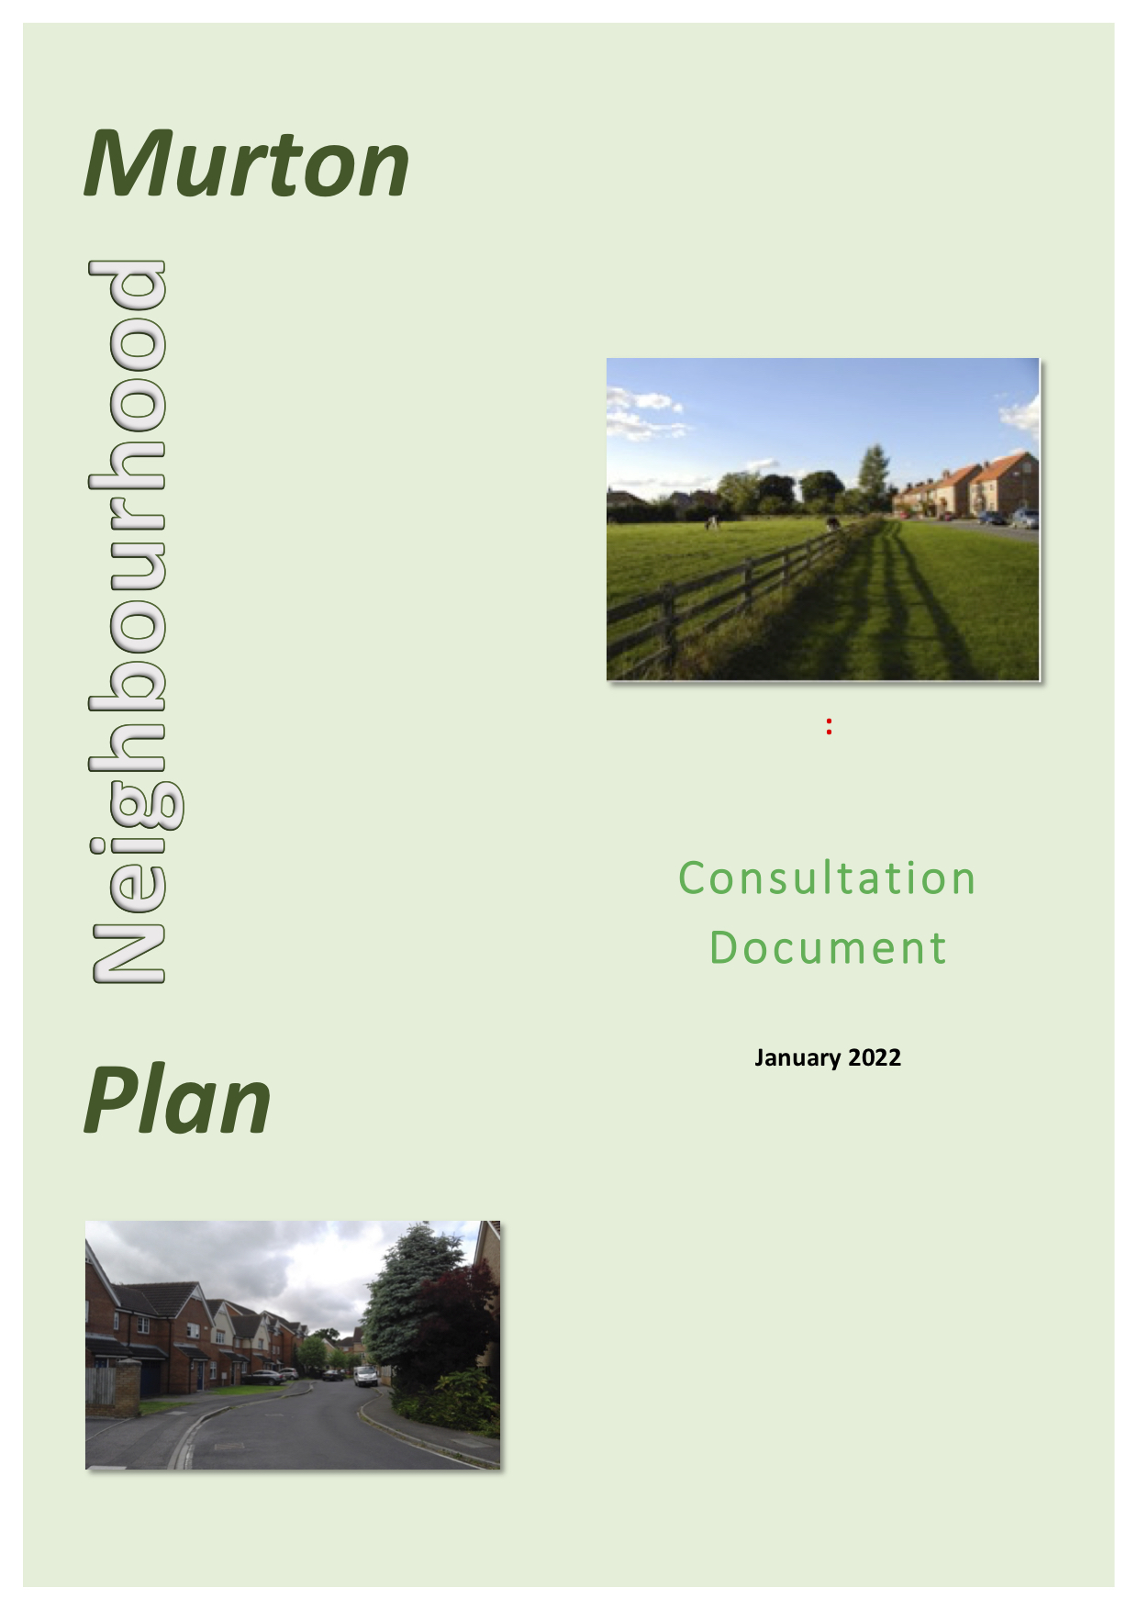

INDEX

Section 1 Introduction
Section 2 Compliance with Neighbourhood Plan Regulations
Section 3 First steps
Section 4 Questionnaires and analyses- Why and how?
Section 5 Other forms of communication
Section 6 Pre-submission consultation
Section 7 Appendices

Appendix 1 A pamphlet from Murton Parish Council to residents and businesses (July 2015)
Appendix 2 Letter to businesses from the Chairman of Murton Parish Council (January 2015)
Appendix 3 Terms of reference of the Murton Parish Neighbourhood Plan Working Party
Appendix 4 Letter to residents from the Chairman of Murton Parish Council (January 2016)
Appendix 5 Questionnaire to all residents (1A) (January 2016)
Appendix 6 Questionnaire to residents on the southern periphery (1B) (June 2016)
Appendix 7 Questionnaire 1A report
Appendix 8 Questionnaire 1B report
Appendix 9 Questionnaire 2A (May-June 2017)
Appendix 10 Questionnaire 2B (November 2017)
Appendix 11 Questionnaire 2A report (November 2017)
Appendix 12 Letter to residents from the Chairman of Murton Parish Council (February 2018)
Appendix 13 Questionnaire 2B report (January 2018)
Appendix 14 Letter to businesses from the Chairman of Murton Parish Council Neighbourhood Plan Working Party (January 2016)
Appendix 15 Questionnaire 1C to businesses (January 2016)
Appendix 16 Questionnaire 1C report
Appendix 17 An invitation to residents and businesses to discuss the Murton Parish Neighbourhood Plan at a Drop-in (September 2016)
Appendix 18 A Newsletter to all households and businesses (August/September 2018)
Appendix 19 Letter from the Chairmen of the Parish Council and the Neighbourhood Plan Working Party to households concerning the pre-submission consultation (April 2021)
Appendix 20 Letter from the Chairmen of the Parish Council and the Neighborhood Plan Working Party to businesses concerning the pre-submission consultation (April 2021)
Appendix 21 Pamphlet outlining the Murton Parish Neighbourhood Plan: The pre-submission stage, for all households and businesses (April 2021)
Appendix 22 A form which could be used for responses (April 2021)
Appendix 23 Email from the Clerk of Murton Parish Council to relevant organisations concerning the pre-submission consultation (April 2021)
Appendix 24 Organisations invited to comment on the draft Murton Parish Neighbourhood Plan
Appendix 25 Murton Parish Council Neighbourhood Plan: Pre-submission Consultation comments and responses (December 2021)

Introduction

  - This report summarises how the Murton Parish Neighbourhood Plan Working Party, on behalf of the Murton Parish Council, consulted and gathered information from residents and businesses in the Parish and from relevant national, regional and local organizations as the Murton Parish Neighbourhood Plan (MPNP) was developed.

Compliance with Neighbourhood Plan Regulations
  - We are guided by Regulation 15 in the Neighbourhood Planning Regulations 2012.
15 — (1) Where a qualifying body submits a plan proposal to the local planning authority, it must include—
- map or statement which identifies the area to which the proposed neighbourhood development plan relates;
- a consultation statement;
- the proposed neighbourhood development plan; and
- a statement explaining how the proposed neighbourhood development plan meets the requirements of paragraph 8 of Schedule 4B to the 1990 Act.

- In this regulation “consultation statement” means a document which—
  - contains details of the persons and bodies who were consulted about the proposed neighbourhood development plan;
  - explains how they were consulted;
  - summarises the main issues and concerns raised by the persons consulted; and
  - describes how these issues and concerns have been considered and, where relevant, addressed in the proposed neighbourhood development plan.

First steps

3.1 An outline of the consultation process prior to the submission of the Neighbourhood Plan is given in Section 4 of the main document of the Murton Parish Neighbourhood Plan submission. The process is described in more detail in this document.
3.2 The City of York Council agreed to the designated area for the Murton Parish Neighbourhood Plan on July 23rd 2015 with the boundary being the existing Parish boundary.
3.3 The Parish Council sent a pamphlet to households and businesses in the Parish (Appendix 1) and a letter and pamphlet to the Chairman of the Murton Business Park Association (Appendix 2).
3.4 The Murton Parish Council established the Murton Parish Neighbourhood Plan Working Party in September 2015 with responsibility for the development of the MPNP in compliance with the Localism Act 2011. Its terms of reference are given in Appendix 3.
3.5 The Working Party had, during its existence, three Parish Councillors and three other members of the Parish, with Cllr Richard Clancey as Chairman.
3.6 The Murton Parish Neighbourhood Plan has been produced alongside the development of the emerging City of York Local Plan and CYC officers offered comments and advice throughout the process.
3.7 The consultation process proved to be very valuable. Its influence can be readily seen in the introductions leading to the 23 Policies. In these introductions evidence for why these Policies are important for the Parish is described in the following order:
- National Planning Policy Framework (NPPF)
- The emerging City of York Local Plan
- Responses from consultations in the Parish
- Where applicable, other information

Questionnaires and analyses — Why and how?

4.1 Why?
Using questionnaires is an important way to find out what people like and dislike about living, or running a business, in the Parish. This information was used to shape the Neighbourhood Plan.

4.2 How (residential)?
For the residents’ questionnaires, we created a two-stage process. In Stage 1 (2016) we asked broad questions, and in Stage 2 (2017) used the responses to create more detailed questions.

4.3 Stage 1 (Questionnaires 1A and 1B)— 2016
4.3.1 In Stage 1, a letter was sent to residents (Appendix 4) together with Questionnaire 1A (Appendix 5) and Questionnaire1B (Appendix 6) which asked two simple open questions:
- Name three things that make living in the Parish attractive to you.
- Name three things that you find disappointing for you in the Parish and which you think can be improved.

4.3.2 The reason for separate questionnaires to residents is that, following the disappointing initial response from households in the southern periphery when we sent Questionnaire 1A to all residents in the Parish, we reissued the original questionnaire to that area later in the year and we analysed the results separately as Questionnaire 1B. This was fortuitous as we received a different set of replies which in retrospect is obvious for as the census (Neighbourhood Plan, Appendix C) points out, there are many differences in the profile of the residents in the two areas, for example, types of employment, housing types, housing tenure, gender and age.
4.4 Analysis of Stage 1 responses
4.4.1 There are two analysis reports of the Stage 1 household questionnaires Questionnaire 1A Report (Appendix 7) and Questionnaire 1B Report (Appendix 8)— relating to the two main residential areas, the village and the southern periphery. Separate analyses also proved helpful in Stage 2 by highlighting any issues particular to one or the other area

4.5 Stage 2 (Questionnaires 2A and 2B)— 2017

4.5.1 With the answers to the 2016 household questionnaires, we were able to construct much more detailed follow-up questionnaires, one for each of the two areas, the village and the southern periphery.

4.5.2 Questionnaire 2A (Appendix 9) was issued to the village area and to businesses in May/June 2017 and Questionnaire 2B (Appendix 10) to households in the southern periphery in November 2017.
4.5.3 A letter, similar to the one sent to the businesses (Section 4.5.4) and the analyses of the feedback, Questionnaire 2A report (Appendix 11) were sent to households in the village area and to businesses in November 2017.
4.5.4 Similarly a letter (Appendix 12) and a copy of the Questionnaire 2B report (Appendix 13) were sent to households in the southern periphery of the Parish in February 2018 .
4.6 How (Business)?
4.6.1 In January 2016, concurrent with the initial residential questionnaire, we sent a letter (Appendix 14) and a questionnaire to all businesses in the Parish, Questionnaire 1C, asking two broad questions (Appendix 15):
- Name three things in the Parish that are good for your business.
- Name three things in the Parish that you find disappointing for your business and which you think can be improved..

4.6.2 The analysis of the response, Questionnaire 1C report (Appendix 16) was sent to businesses in June 2016.
4.6.3 Following the Stage 2 residential questionnaires in 2017, businesses were sent the report to Questionnaire 2A (Appendix 11) and invited to comment on it with respect to their own business.

Other forms of communication

5.1 Minutes of all meetings of the Murton Parish Neighbourhood Plan Working Party were sent to the Parish Council. They and all reports to the Parish Council, sent monthly, were published on the Parish Council website and can be viewed at
http://www.murtonparishcouncilyork.org/neighbourhood-plan/previous-reports.html

5.2 Further a website dedicated to the Neighbourhood Plan, was created by the Working Party and this contained all the documents it created. It can be located at
https://murtonneighbourhoodplan.org.uk/#content

5.3 A pamphlet was sent by the Chairman of the Working Party to all households in the Parish in August 2016 inviting all residents to a Drop-in in the following month and giving a further explanation of the Neighbourhood Plan (Appendix 17).

5.4 A letter to all businesses was also sent by the Chairman of the Working Party giving notice of the Drop-in and, as above, a further explanation of the Neighbourhood Plan (Appendix 17).

5.5 A Newsletter (4 pages), which gave an update of the work so far, was sent to all households and to the businesses in the Parish (Appendix 18).

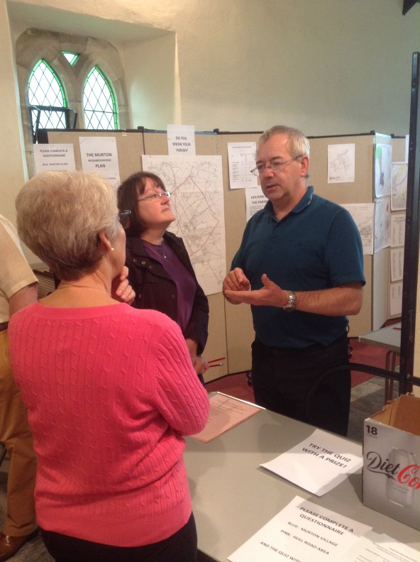

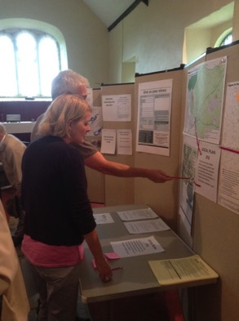

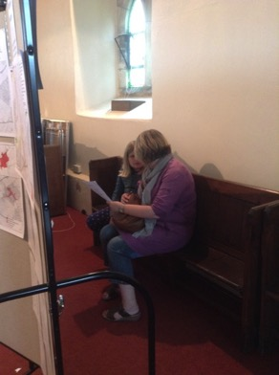

At the Drop-in, September 2016

Pre-Submission consultation.

6.1 The pre-submission consultation involved all households and businesses in the Parish. Each received a letter from the Chairman of the Parish Council (Appendices 19 and 20) and an 8-page pamphlet again explaining the role of Neighborhood Planning and outlining the key proposals and giving all the Policy statements (Appendix 21).

6.2 A simple form could be used by respondents (Appendix 22)

6.3 An email was sent to relevant national, regional and local organisations with a stake in the Parish asking for comments on the pre-submission documents (Appendix 23). A list of these organisations is given in Appendix 24.

6.4 The planned Drop-in, in parallel with the Pre-submission consultation, could not take place due to Covid restrictions

6.5 However, hard copies of all the relevant documents were exhibited on the Working Party’s dedicated website and made available at the City Library, the Library in Tang Hall, and the Yorkshire Museum of Farming. They could also be obtained from the Clerk of the Parish Council

6.6 The responses from residents, businesses and organisations were analysed and each was answered and, where appropriate, the Pre-submission document was altered. For ease of reading, a Table was constructed showing the comments and what changes were made (Appendix 25).

Appendices

Appendix 1 A pamphlet from Murton Parish Council to residents and businesses (July 2015)
Appendix 2 Letter to businesses from the Chairman of Murton Parish Council (January 2015)
Appendix 3 Terms of reference of the Murton Parish Neighbourhood Plan Working Party
Appendix 4 Letter to residents from the Chairman of Murton Parish Council (January 2016)
Appendix 5 Questionnaire to all residents (1A) (January 2016)
Appendix 6 Questionnaire to residents on the southern periphery (1B) (June 2016)
Appendix 7 Questionnaire 1A report
Appendix 8 Questionnaire 1B report
Appendix 9 Questionnaire 2A (May-June 2017)
Appendix 10 Questionnaire 2B (November 2017)
Appendix 11 Questionnaire 2A report (November 2017)
Appendix 12 Letter to residents from the Chairman of Murton Parish Council (February 2018)
Appendix 13 Questionnaire 2B report (January 2018)
Appendix 14 Letter to businesses from the Chairman of Murton Parish Council Neighbourhood Plan Working Party (January 2016)
Appendix 15 Questionnaire 1C to businesses (January 2016)
Appendix 16 Questionnaire 1C report
Appendix 17 An invitation to residents and businesses to discuss the Murton Parish Neighbourhood Plan at a Drop-in (September 2016)
Appendix 18 A Newsletter to all households and businesses (August/September 2018)
Appendix 19 Letter from the Chairmen of the Parish Council and the Neighbourhood Plan Working Party to households concerning the pre-submission consultation (April 2021)
Appendix 20 Letter from the Chairmen of the Parish Council and the Neighbourhood Plan Working Party to businesses concerning the pre-submission consultation (April 2021)
Appendix 21 Pamphlet outlining the Murton Parish Neighbourhood Plan: The pre-submission stage, for all households and businesses (April 2021)
Appendix 22 A form which could be used for responses (April 2021)
Appendix 23 Email from the Clerk of Murton Parish Council to relevant organisations concerning the pre-submission consultation (April 2021)
Appendix 24 Organisations invited to comment on the draft Murton Parish Neighbourhood Plan
Appendix 25 Murton Parish Council Neighbourhood Plan: Pre-submission Consultation comments and responses (December 2021)

Appendix 1
A pamphlet from Murton Parish Council
to residents and businesses (July 2015)
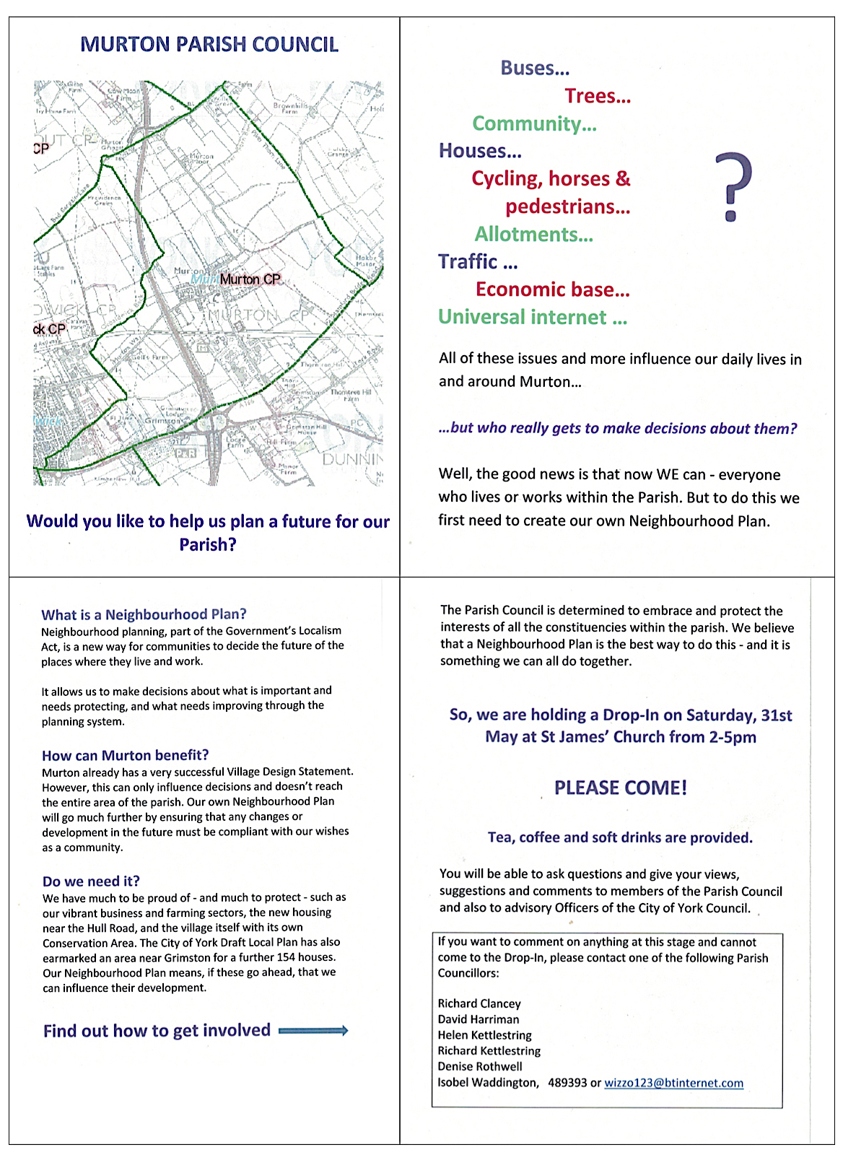`

Appendix 2
Letter to businesses from the Chairman of Murton Parish Council
(January 2015)

MURTON PARISH COUNCIL
From Isobel Waddington
Murton Hall
York YO19 5UQ
Email: wizzo123@outlook.com
July 2015
Dear Mr Hogg
MURTON PARISH NEIGHBOURHOOD PLAN
Now that the City of York Council has agreed to our proposal to create a Neighbourhood Plan, I am writing to invite you and your colleagues to meet with members of the Parish Council to discuss the process at the earliest possible stage.
We are conscious that local businesses play an important part in our Parish and so we are extending this invitation as our first step in the consultation process for the new Plan. Further, we know and understand that you have concerns and we hope that we can explore these at this first meeting.
I would be grateful if you could indicate whether a first meeting one afternoon in August or very early September would be convenient.
Yours sincerely

Isobel Waddington
Chairman, Murton Parish Council

cc James Stephenson

Appendix 3

Terms of reference of the Murton Parish Neighbourhood Plan Working Party

MURTON PARISH NEIGHBOURHOOD PLAN WORKING PARTY

Terms of reference

1. Introduction
Murton Parish Council submitted a request to the City of York Council that the whole parish should be designated a neighbourhood area using the legislation of the Localism Act, 2011. This was granted on July 23rd 2015 and thus the Murton Parish Council is enabled to produce a neighbourhood plan.
Where a parish or town council chooses to produce a neighbourhood plan, it should work with other members of the community who are interested in, or affected by, the neighbourhood planning proposals thus allowing them to play a role in preparing the neighbourhood plan.

Murton Parish Council established a Neighbourhood Plan Working Party[1], which allows the Parish Council to appoint local people (who need not be parish councillors) to this body[2]. The relationship between these two groups shall be transparent to the wider public.

The Working Party shall be dissolved once the Murton Neighbourhood Plan has been assessed and approved by the independent examiner.
The Working Party has a purely advisory function. It is the Parish Council that formally submits the Murton Parish Neighbourhood Plan to the City of York Council.

These Terms of Reference shall apply from the date of this document and retrospectively where relevant to the date of the inception of the Working Party and will be reviewed throughout the project and amended as and when required by the Parish Council.

2. Membership of the Working Party
2.1 The Working Party shall be formed from members of the Murton Parish Council and from members of the local community who shall be invited by the Parish Council to serve on it
2.2 The Working Party shall consist of a maximum of 6 members
2.3. The Chairman of the Working Party shall be appointed by the Murton Parish Council
2.4 The membership of the Working Party shall be regularly reviewed and confirmed by the Parish Council
2.5 All members of the Parish Council may attend meetings of the Working Party.

3. Responsibilities of members of the Working Party
The members of the Working Party shall
3.1 declare any personal interest that may be perceived as being relevant to any decisions or recommendations made by it. This may include membership of an organisation, a body or group whose purposes include the influence of public opinion or policy, ownership of interest in land (directly or indirectly) or a business or any other matter likely to be relevant to the work undertaken by the Working Party

3.2 manage the preparation of the Neighbourhood Plan as agreed by the Parish Council and the Working Party itself[3]

3.3 ensure that the preparation of the Neighbourhood Plan is an inclusive, open and transparent process to all groups in the Parish and to those wishing to undertake development or be involved in the plan making process

3.4 meet on a regular basis[4].

4. Responsibilities of the Parish Council
The Parish Council shall

4.1 have the responsibility to provide the necessary funding to enable the Working Party to function effectively[5]

4.2 carry out all statutory duties associated with the Neighbourhood Plan and engage with City of York Council when necessary during the process of producing the Plan[6]

4.3 facilitate, when required, contact with the relevant statutory bodies or parties who must be consulted during the plan making process.

[1] Under section 102(4) of the Local Government Act 1972.
[2] Members of the Working Party have voting rights under section 13(3), 4(e) or 4(h) of the Local Government and Housing Act 1989.
[3] This includes the arrangement of meetings; obtaining and assessing evidence about the needs and aspirations of the Parish; constructing questionnaires and analysing the results obtained from questionnaires or other data and evidence received during the planning process; liaising with the City of York Council and other relevant statutory organisations and stakeholders to secure their input in the process; identifying sources of funding; assisting the Parish Council to prepare the necessary papers associated with funding; informing the Parish Council of progress on a regular basis; supporting the City of York City Council and Murton Parish Council during the referendum process
[4] It will meet when there is business to transact. However, the Parish Council wishes to have regular reports given to it for its meetings
[5] The Parish Council will support the preparation of the Murton Neighbourhood Plan providing sufficient assistance and financial resources to ensure the plan is prepared expeditiously providing that overall expenditure falls within the budget allocated by the Council or such funds as can be secured by the Parish Council from external bodies.
[6] The City of York Council will provide assistance under the statutory provision of the Localism Act 2011.

Appendix 4

Letter to residents from the Chairman of Murton Parish Council
(January 2016)

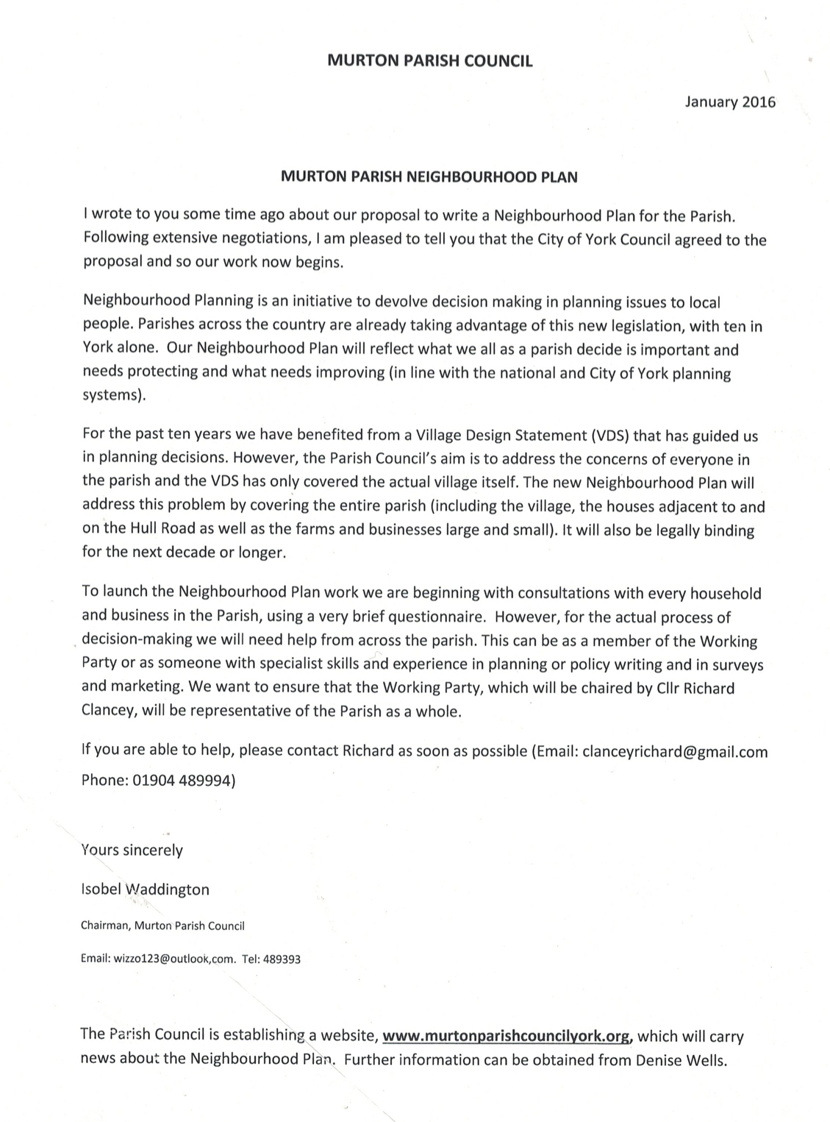

Appendix 5
Questionnaire to all residents (1A) (January 2016)

Murton Parish Neighbourhood Plan
Questionnaire 1A: January 2016

We would be grateful if you would complete this brief questionnaire for the household. Details of collection are given below.
- Where do you live? Please circle the appropriate letter A-D
A Meam Close, Moins Court, Redbarn Drive

B Hull Road, Tranby Avenue, Cavendish Grove, Grimston Bar, Stamford Bridge Road

C Murton Garth

D Main Street, Moor Lane, Murton Lane, Murton Way, Sandy Lane, Smary Lane

- Is the house a) owner-occupied or b) rented? (Please circle the correct answer)

- Name three things that make living in the Parish attractive to you.

1.

2.

3.

- Name three things that you find disappointing for you in the Parish and which you think can be improved.
1.

2.

3.
Appendix 6
Questionnaire to residents on the southern periphery (1B) (June 2016)

Murton Parish Neighbourhood Plan
Questionnaire: June 2016
Address: Meam Close, ,
Redbarn Drive
Moins Court
Hull Road,
Cavendish Grove
Tranby Avenue,

e

- Is the house owner-occupied or rented?

- Name three things that make living in the Parish attractive to you.
1.

2.

3.

- Name three things that you find disappointing for you in the Parish and which you think can be improved.
1.

2.

3.
Appendix 7
Questionnaire 1A report

MURTON PARISH NEIGHBOURHOOD PLAN
Questionnaire Analysis 1A:
Households in the village

Introduction
There are two main settlements in the Parish, one, the village, and the other along the southern edge of the Parish (Hull Road, Cavendish Grove, Tranby Avenue, Redbarn Drive, Meam Close and Moins Court), the village having 139 dwellings and second settlement having 119.
A reasonable 34 village households (or 25%) responded to the initial questionnaire but the southern periphery response was very disappointing. So, it was decided to split the feedback into the two areas, questionnaires 1A for the village and 1B for the southern periphery, repeating 1B later in the year to encourage a better response.
Both questionnaires were identical and designed to facilitate the freest feedback. The questions asked simply for ‘three things that make living in the Parish attractive to you’ and ‘three things that you find disappointing for you in the Parish and which you think can be improved’.
This report covers the village response – the southern periphery feedback can be found in Questionnaire Analysis 1B..

An overview of the answers from households in the village

Below is a summary of the wide-range of responses to the open questions.

QUESTION ONE: ‘Three things that make living in the Parish attractive to you’
PLEASE NOTE: Respondents came up with their own phrases instead of being asked to agree or disagree with set statements. This means that in the results below if, say, 60% had said “we like the trees”, it did not mean that 40% do not like the trees.

Four themes emerged:

- Setting
79% enjoyed ‘a quiet rural village’, ‘an agricultural environment’, ‘a village atmosphere’, ‘rural character’ and ‘rural setting’. Several commented on the value of the conservation area and that ‘there had not been over-development’. One cited living in an ‘attractive, unspoilt and traditional village’. And another stated that the village ‘does not feel like a commuter village’ especially having the Farming Museum and Livestock Centre.

- Community
50% commented on ‘friendliness’, ‘a strong community spirit’, ‘wonderful neighbours’ or ‘an active community’.

- Convenience
74% considered it to be a very good location for rail and road (A64) connections, and referred to the advantages of living in a village that was so close to the city.

- Facilities
29% commented on the benefit of having a local pub, although several were worried that it might be closed.

QUESTION 2: ‘Three things that you find disappointing for you in the Parish and which you think can be improved’

Five themes emerged:

- Traffic
71% complained of the speed and density of traffic through the lanes and the centre of the village. One response noted that the ‘traffic speeds were dangerous’ and several identified HGVs using the lanes and not abiding by the weight restrictions.

- Footpaths
29% were concerned about the state of the footpaths, exacerbated by the fast traffic (particularly the poor state of the footpath alongside Murton Way leading to Osbaldwick which is severely restricted because of the hedges growing over it). Several commented to on the lack of a footpath along Murton Lane from the village to the Stamford Bridge Road to enable residents to walk to the Farming Museum and the Livestock Centre.

- Bus service
38% commented on the infrequent bus service from York and felt that this was a significant downside to living in the village.

- Facilities
15% were unhappy there were no facilities for children (for example a playground) in the village. Others commented on the potential loss of the pub, 2 commenting on the lack of support, which with the views of others who saw the pub as a positive asset (above), indicates the importance of the pub in the life of the village. 3 households pointed out that there were there were no social activity centres in the village and no post office or shop.
3 households commented on the poor broadband service.

- Anti-social behaviour
20% mentioned rubbish and tipping, one response citing pavement parking, and two mentioned dog fouling.

- Drainage
18% felt that the drainage should be improved with frequent bouts of standing water in the roads of the low-lying village.

Appendix 8
Questionnaire 1B report

MURTON PARISH NEIGHBOURHOOD PLAN
Questionnaire Analysis 1B:
Households along the southern edge of the Parish

Introduction
As explained in the Questionnaire 1A report, there are two main settlements in the Parish, the village and the southern edge of the Parish (Hull Road, Cavendish Grove, Tranby Avenue, Redbarn Drive, Meam Close and Moins Court). The village has 139 dwellings and second settlement has 119.

Having received only three returns to the initial questionnaire from the southern settlement, we decided on a new strategy to encourage better responses from this part of the Parish.

Using the questionnaire, we conducted face to face discussion with households. This was done on two consecutive Saturdays in June 2016, dividing the area into the estate (Redbarn Drive, Meam Close and Moins Court) and the remaining households in Cavendish Grove, Tranby Avenue and along the Hull Road. This direct approach was much more successful and we obtained answers from 49 households, 39%.

The questions asked were the same as for Questionnaire 1A – ‘name three things that make living in the Parish attractive to you’ and ‘name three things that you find disappointing for you in the Parish and which you think can be improved’

The range of responses reflected the different populations in the southern periphery - the age profile differs from that in the village, and there is high proportion of rented accommodation - and we obtained a different profile of answers from those in the new estate (Redbarn Drive, Meam Close and Moins Court) to those living in older houses (Hull Road, Cavendish Grove and Tranby Avenue). However, as the summary below shows, common themes clearly emerged.

- An overview of the answers from households in Redbarn Drive, Meam Close and Moins Court (28 replies)

The overwhelming impression given was that there was considerable satisfaction about living in this area.

a) Positive things about living in the Parish

18 considered commented that it was quiet and/or clean. And the words ‘friendly’ and ‘no trouble’ were used. The third most common positive thing was location, but for a variety of reasons - the proximity of the city, the closeness to a sports centre, a good school, a good bus service (but see ‘Disappointing Things’ below) local amenities (a garage, shops). Also mentioned was the attractive way the estate had been set out with green spaces.

b) Disappointing things about living in the Parish

Of the comparatively few disappointments, the most frequently stated one was about noise from the adjacent ‘B and Q’ store and the fear that if Sainsburys take over the tenancy of the store, this problem may be exacerbated.

Two respondents were deeply troubled by inconsiderate nearby neighbours (who were students). A few cited lack of social life due to the large number of transient students. Fast traffic was a concern (along the Hull Road and the Osbaldwick Link Road which connects the estate to the Hull Road and thus York). The bus service generated as many complaints as positive comments. This may be a function of age and mobility.

- An overview of the answers from households in Hull Road, Cavendish Grove, Tranby Avenue (21 replies)

As in the estate, the overwhelming impression was of considerable satisfaction about living in this area.

a) Positive things about living in the Parish

The nearby facilities delivered the overriding positive impact; these included good schools and good shops. Good access to and the proximity of the city was also frequently mentioned. The bus service is well regarded.

Although less so than on the estate, the neighbourhood is regarded as ‘quiet’ and enjoying ‘a quiet family atmosphere’, and with large gardens and traditional housing there was ‘not much trouble’.

b) Disappointing things about living in the Parish

The considerable number of short tenancies were cited as a nuisance (too many HMOs, proliferation of letting boards, too many students, parking in the street). The nearby businesses were also criticised (B and Q noisy for the noisy night-time fork lift trucks and the garage for opening early).

Due to their location, traffic affected the householders more than it did those living on the estate. Complaints included speeding buses, HGVs and well cars along the Hull Road, cyclists on paths, cars using the street for U turns, and street parking.

Appendix 9
Questionnaire 2A (May-June 2017)
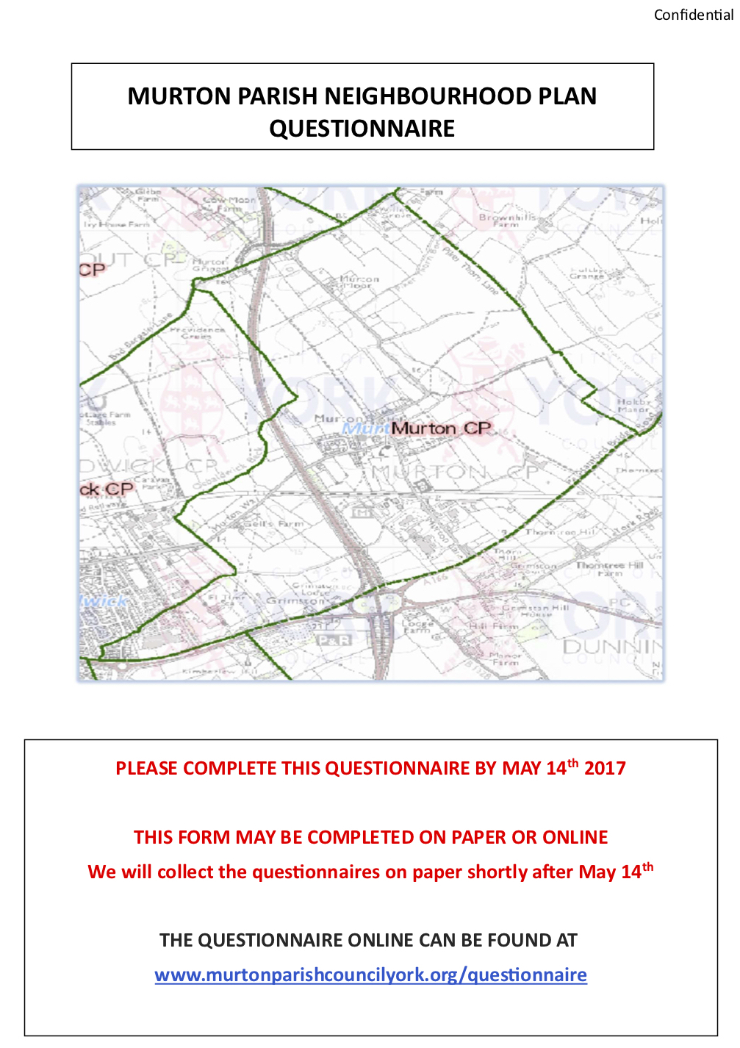
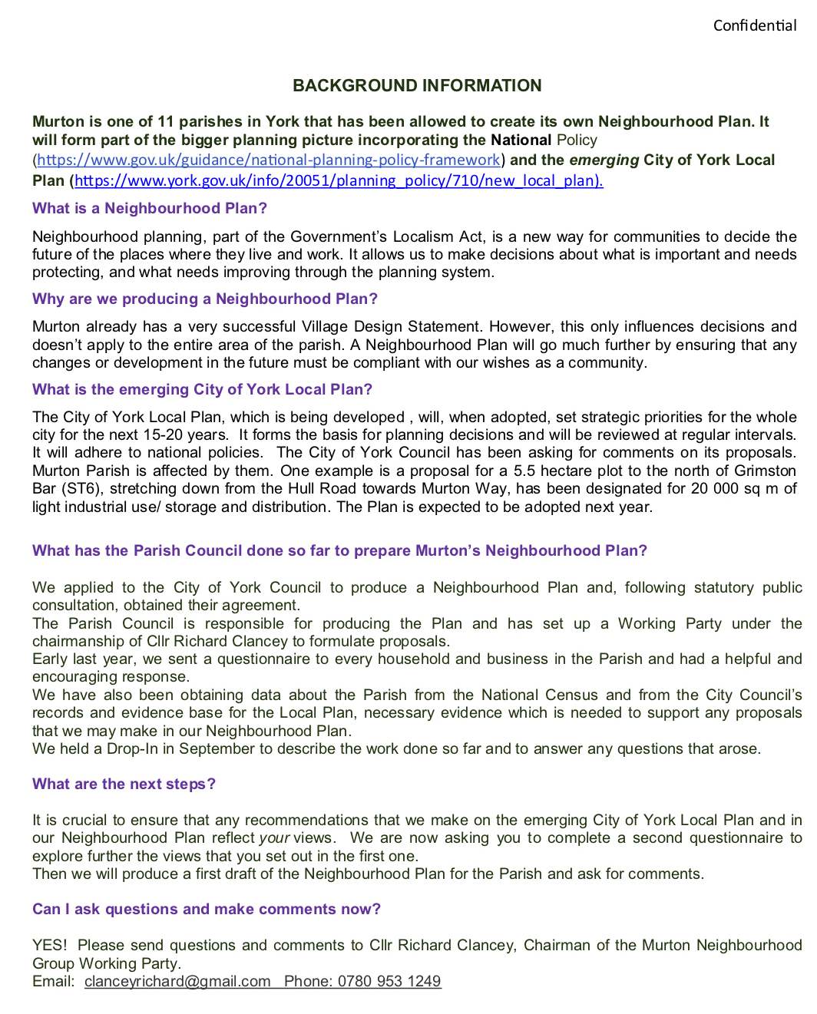

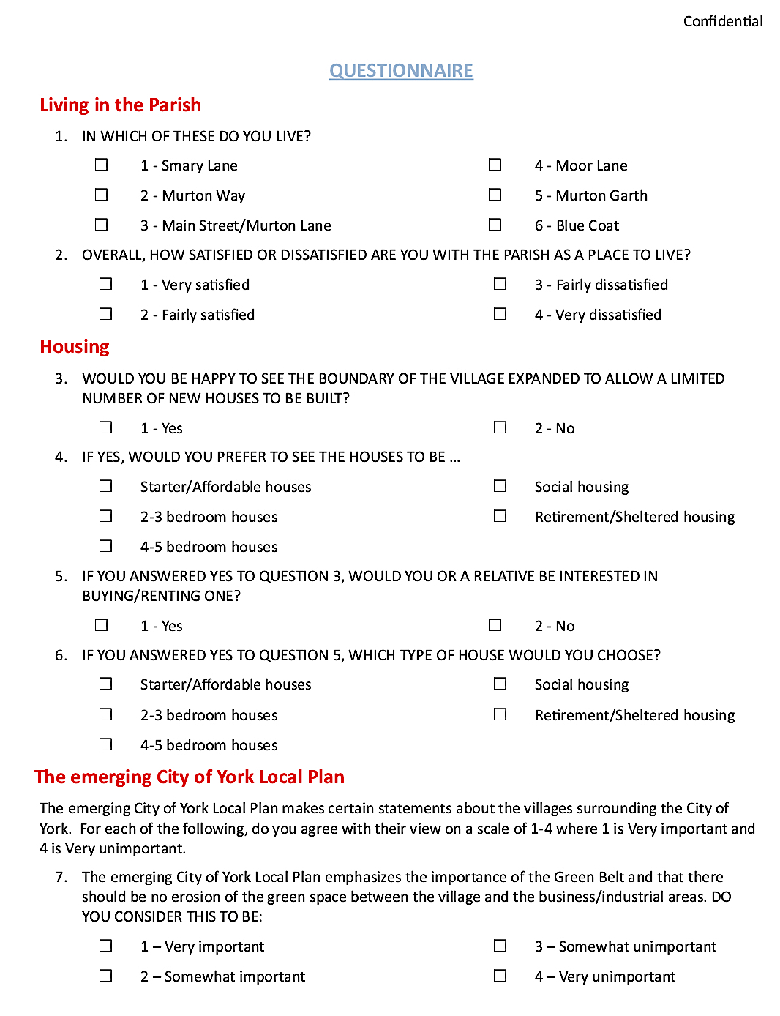

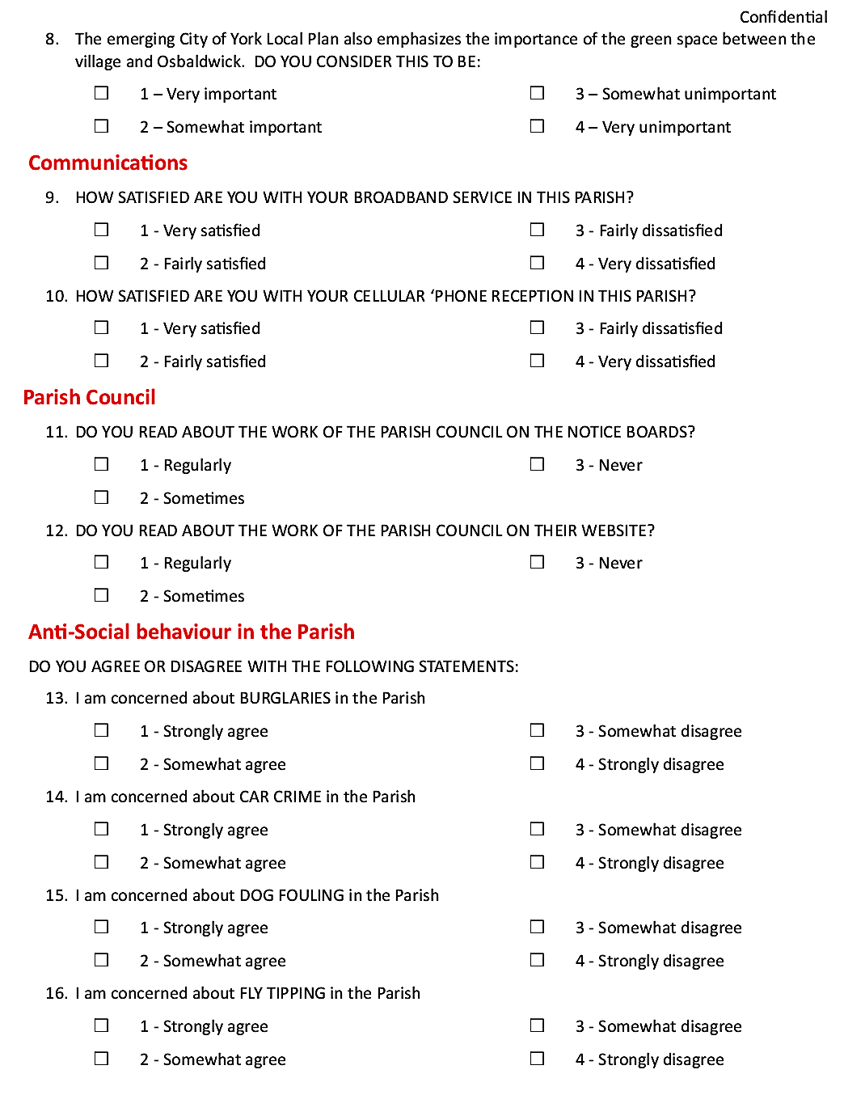

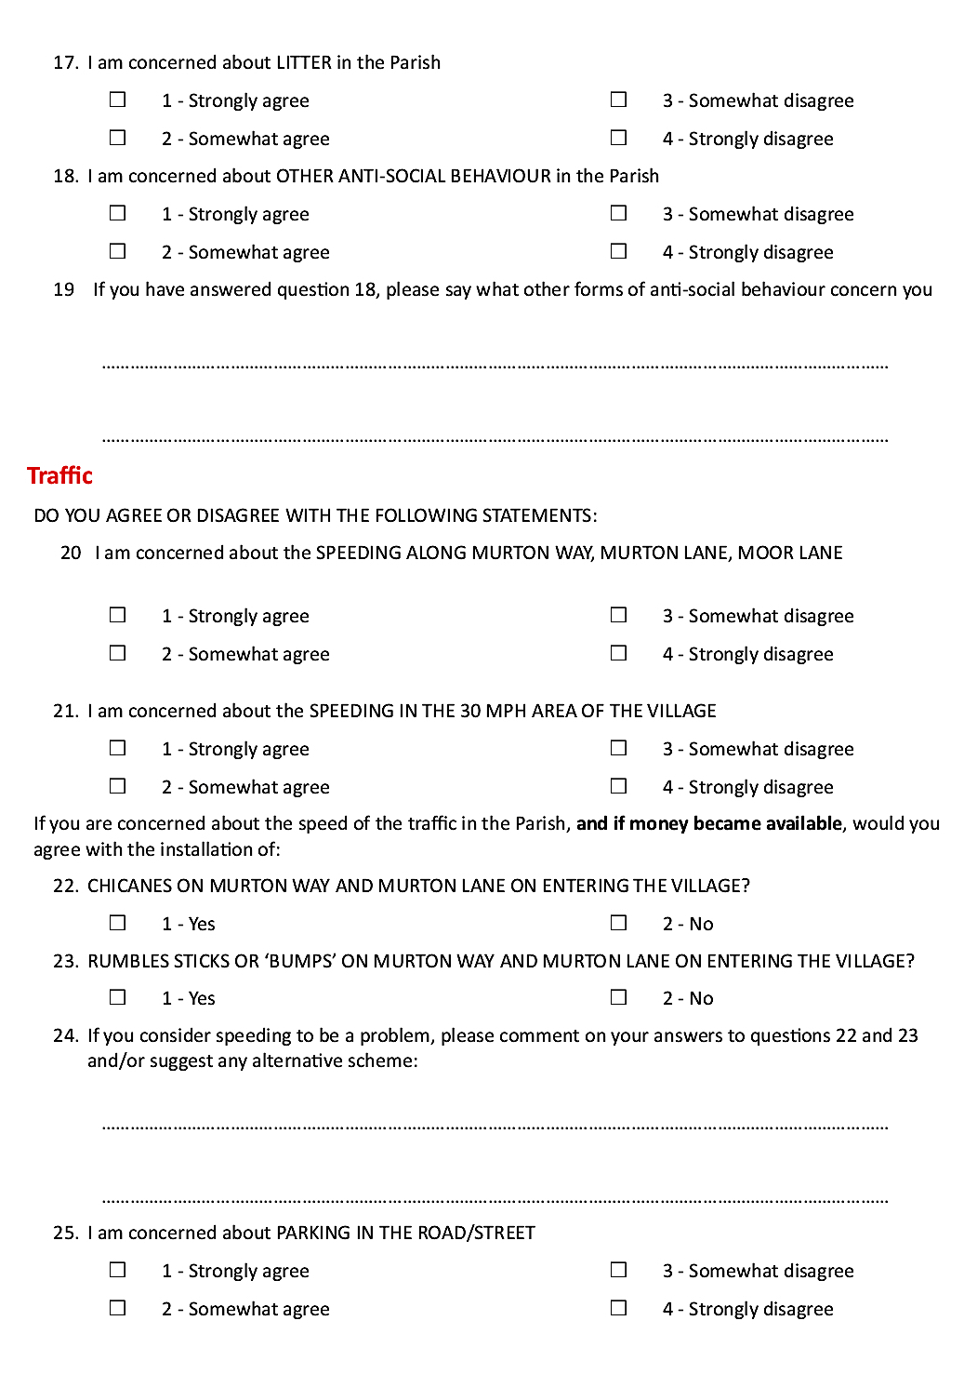

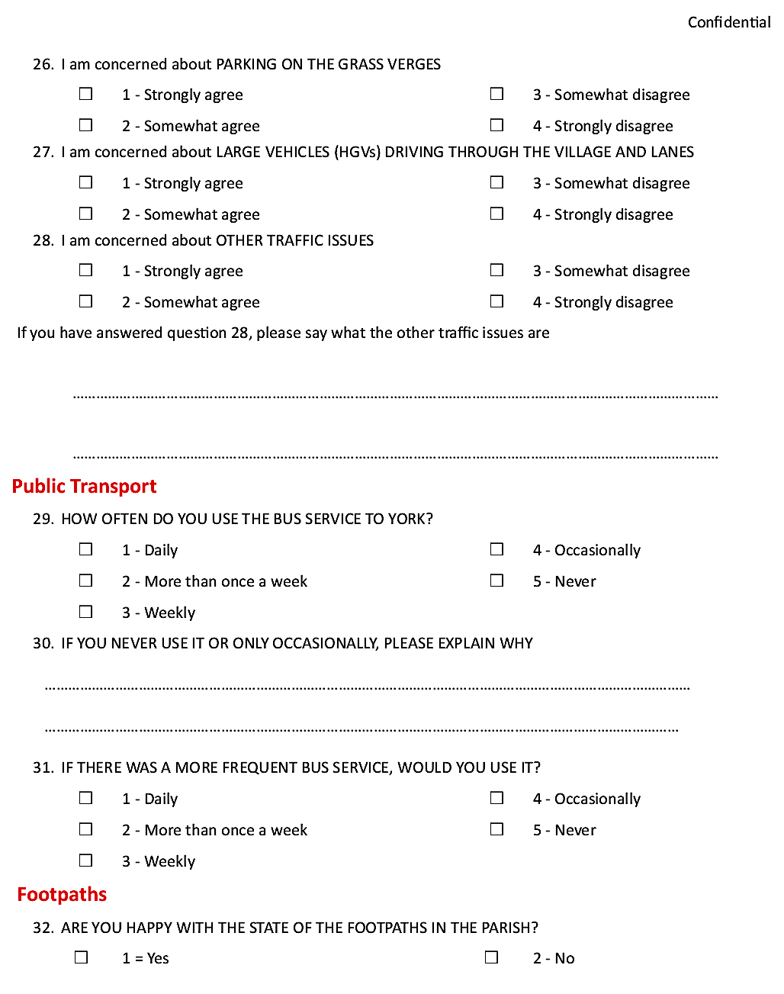

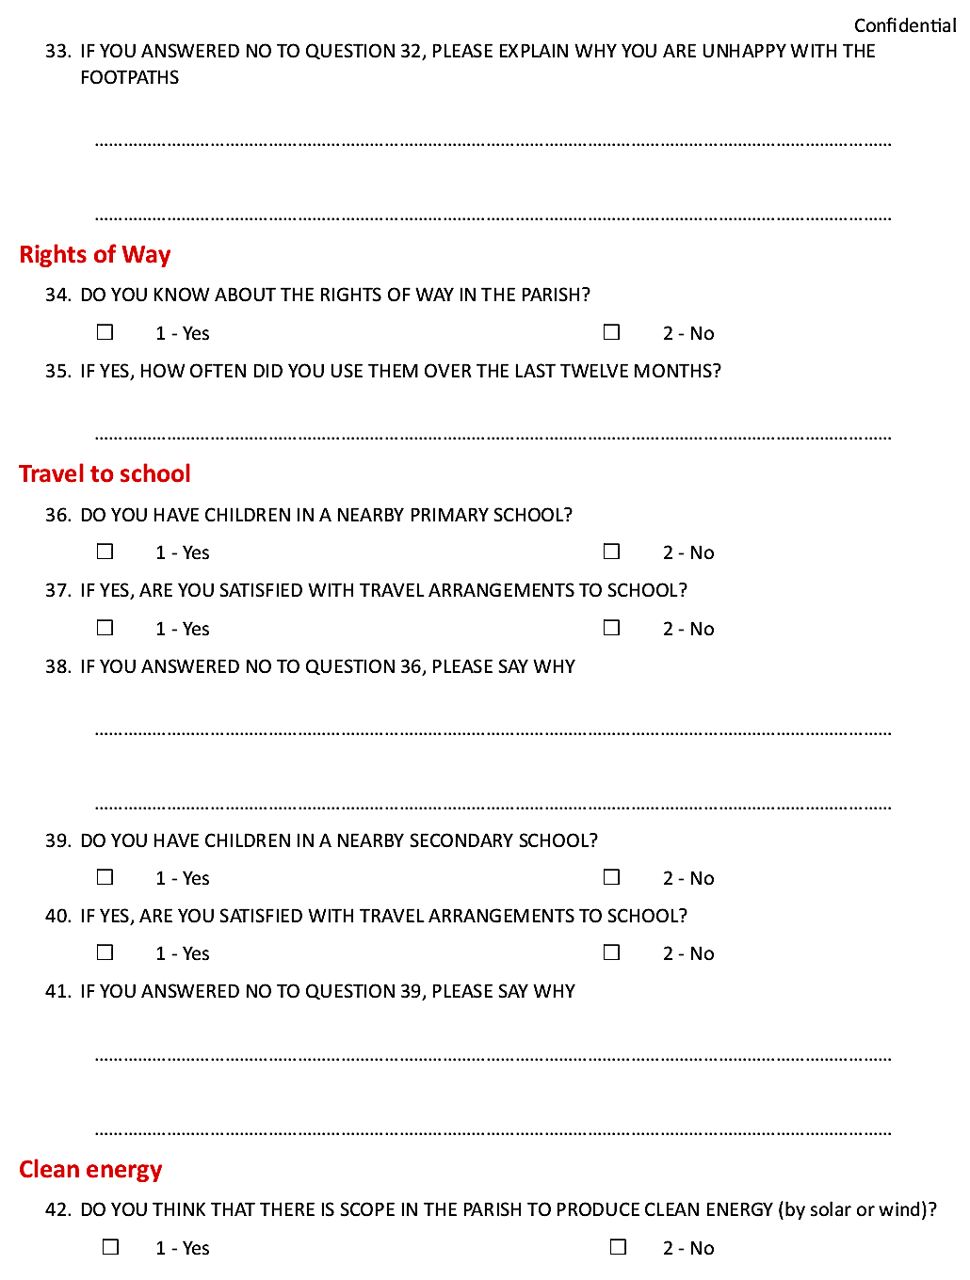

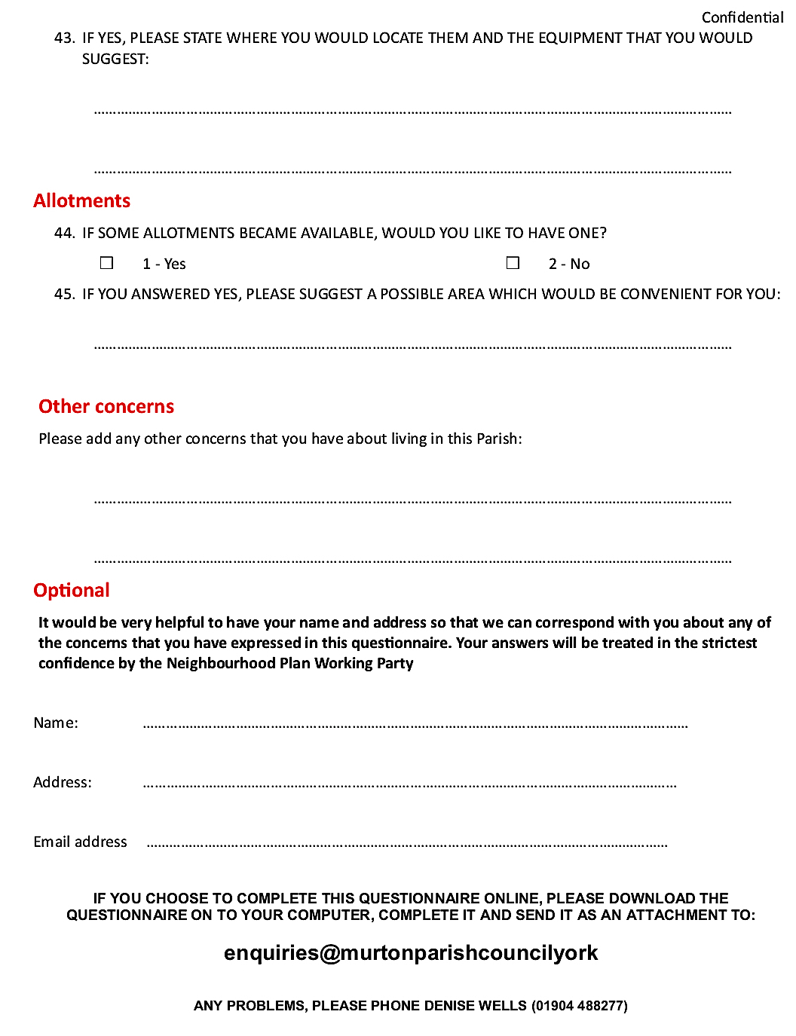

Appendix 10
Questionnaire 2B (November 2017)

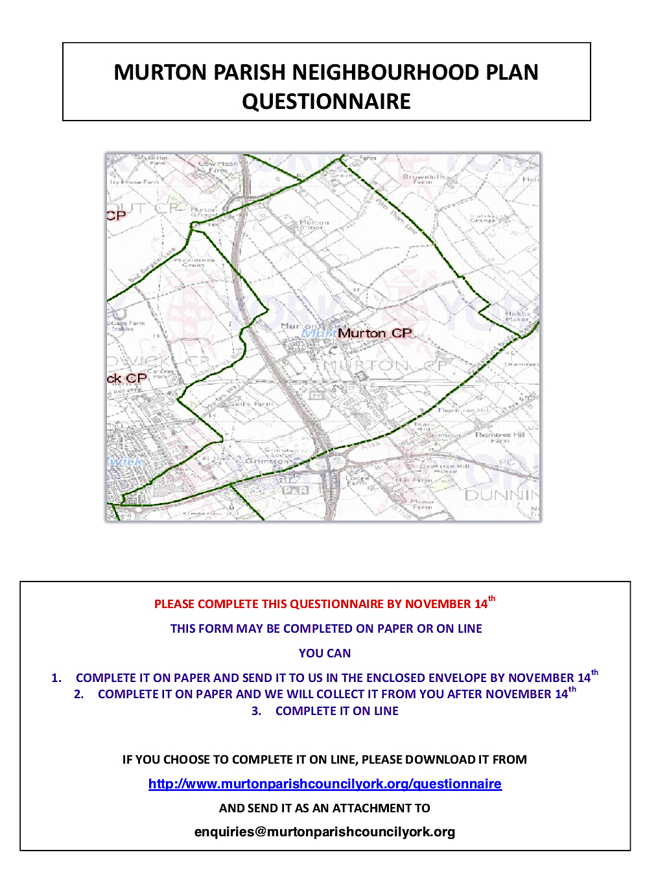

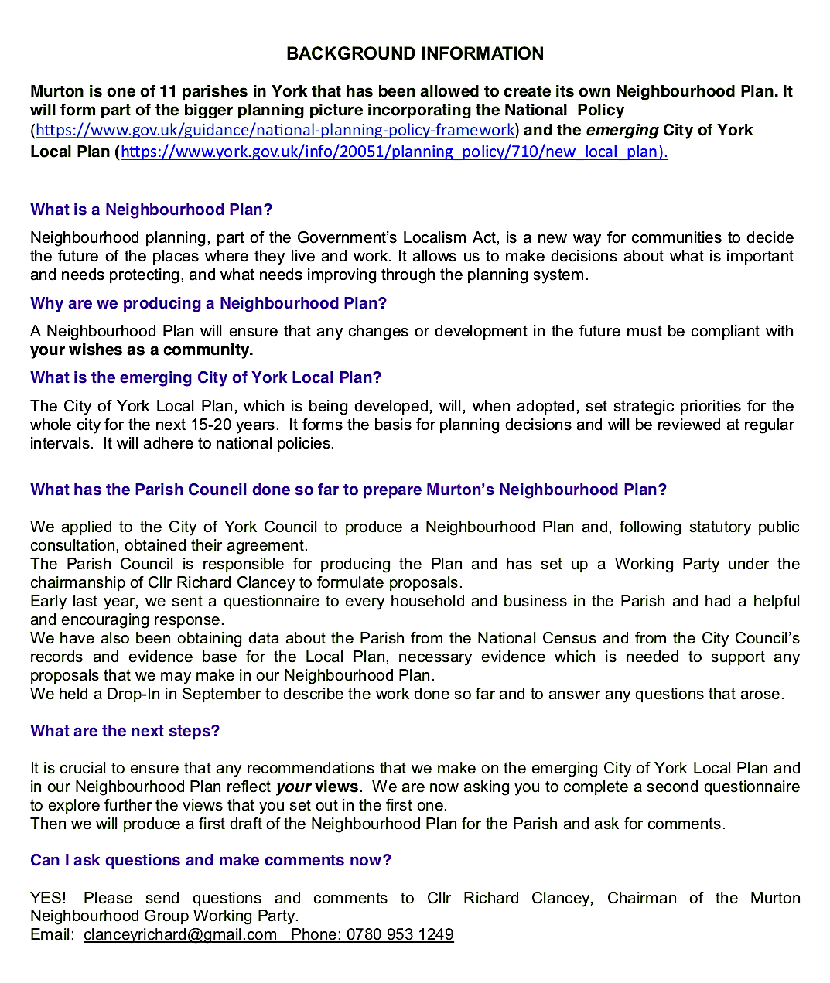

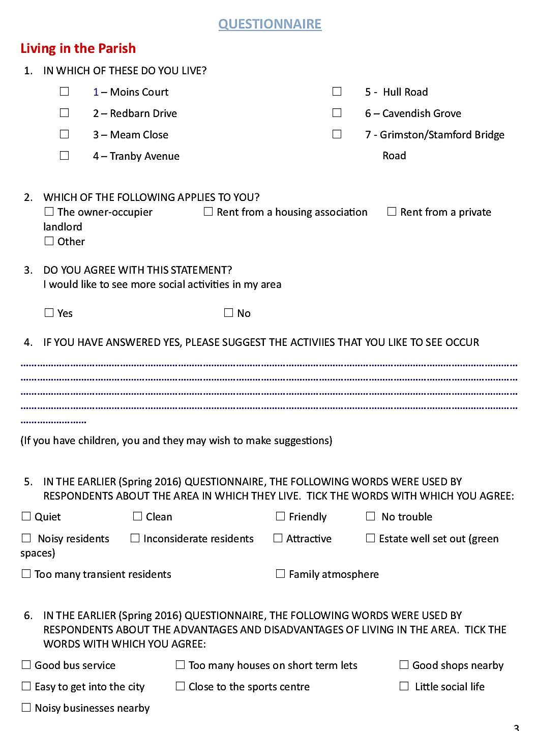

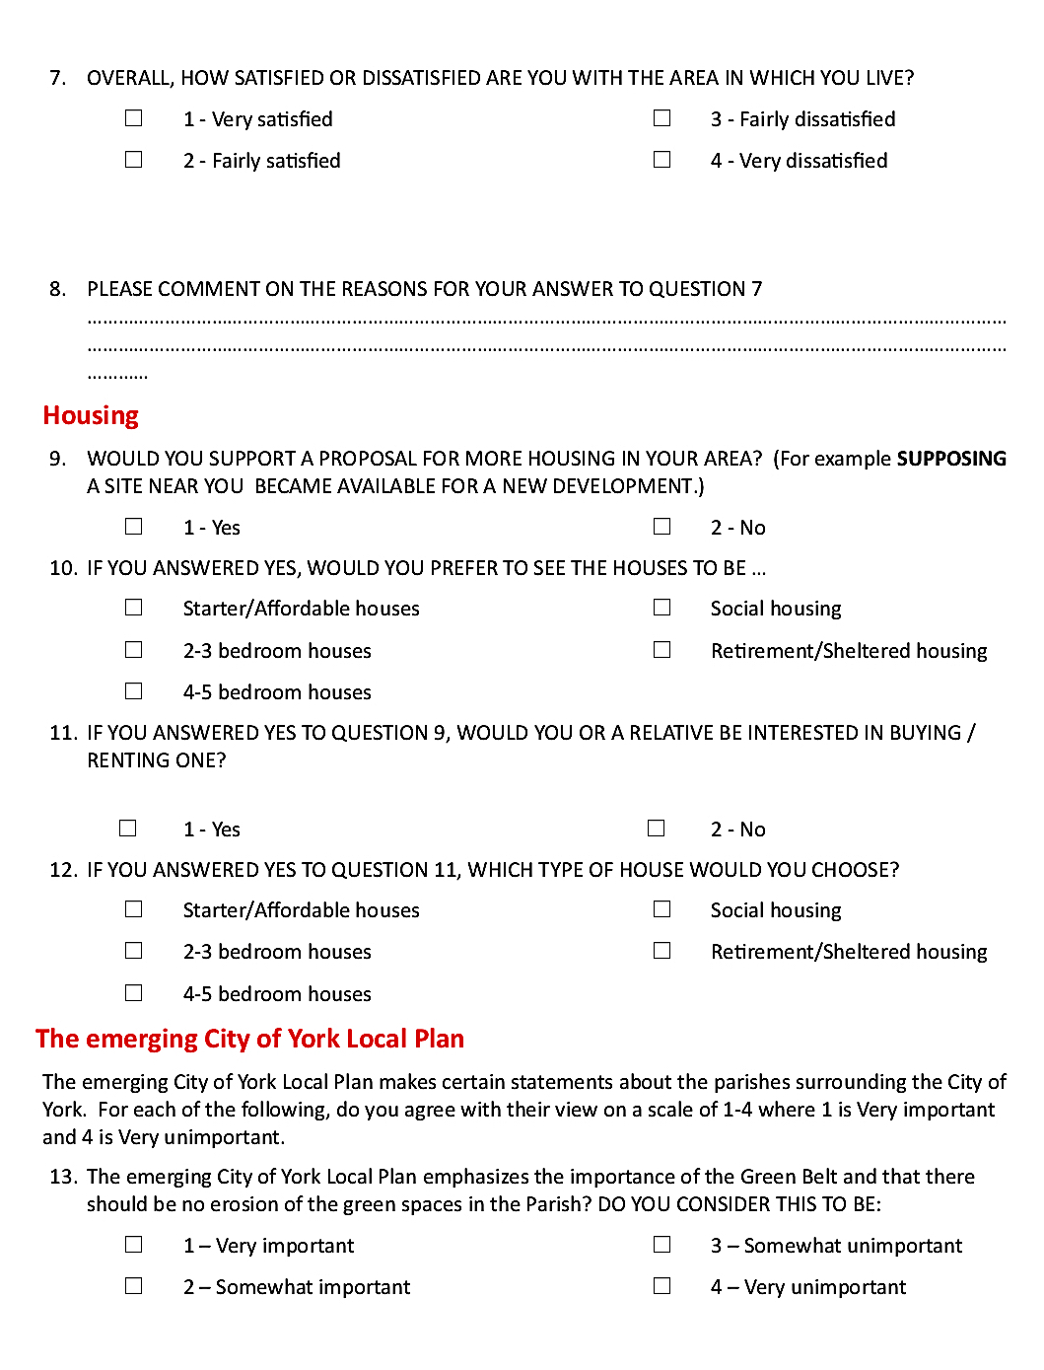

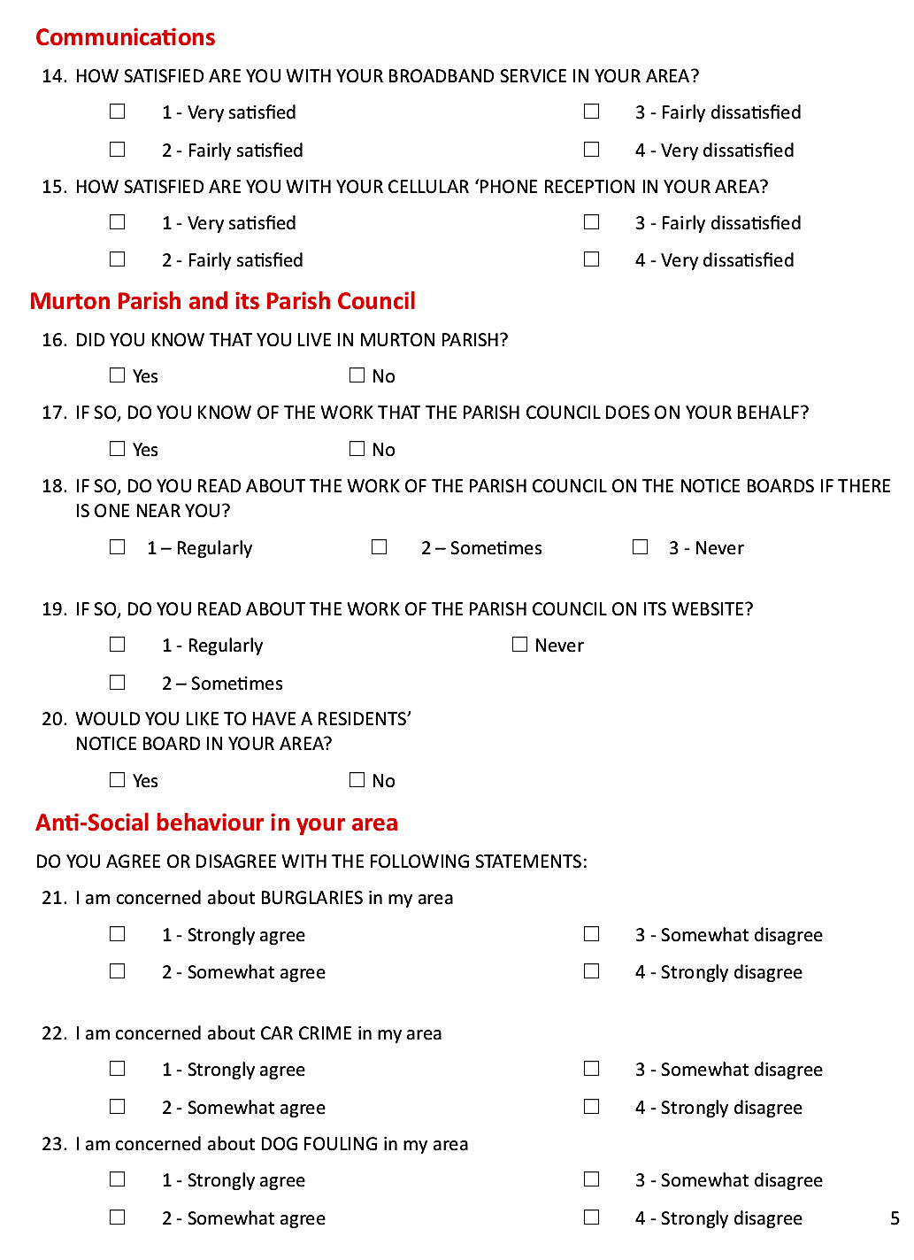

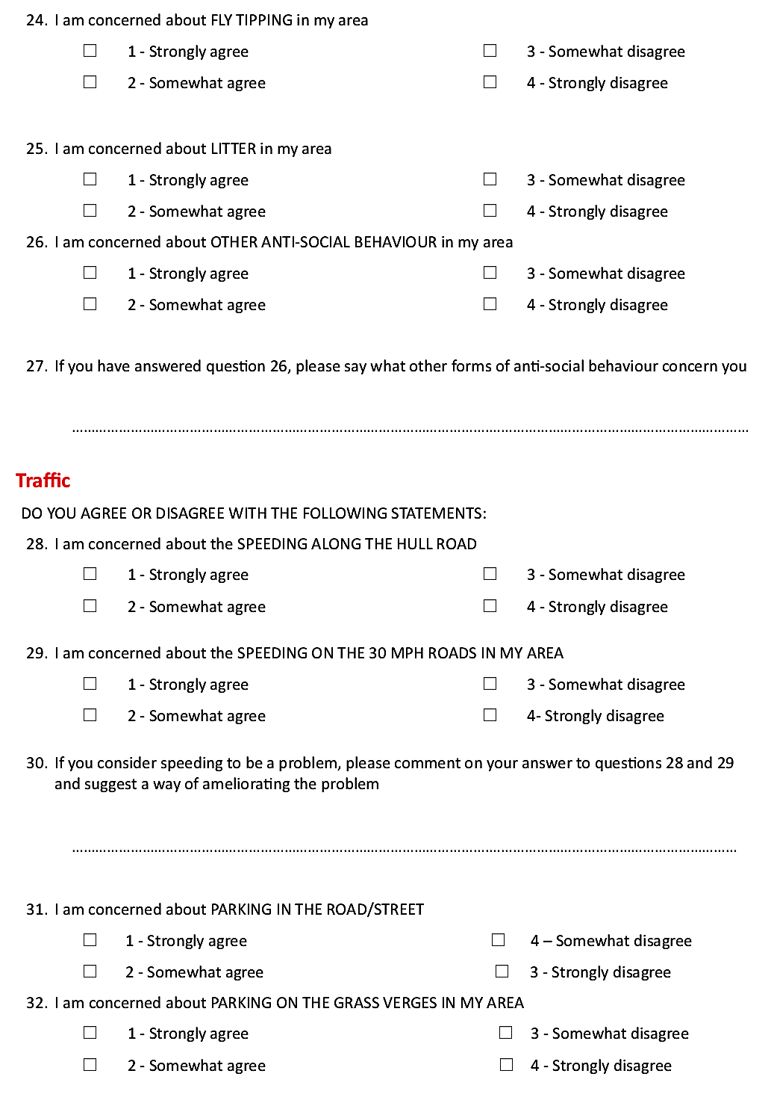

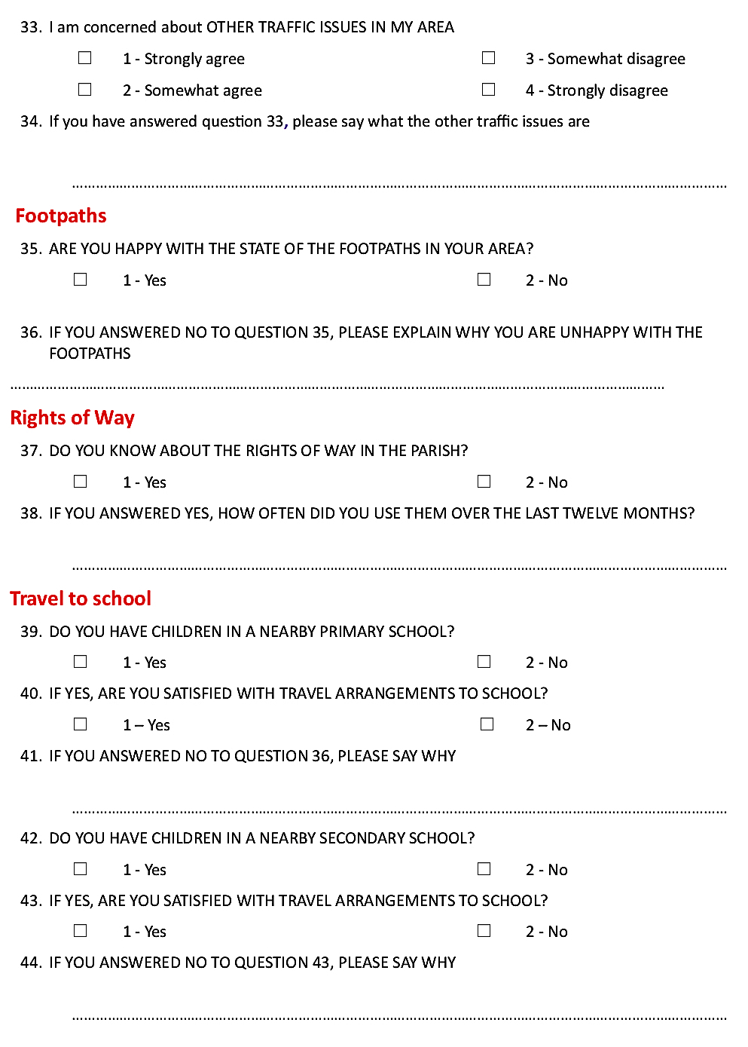

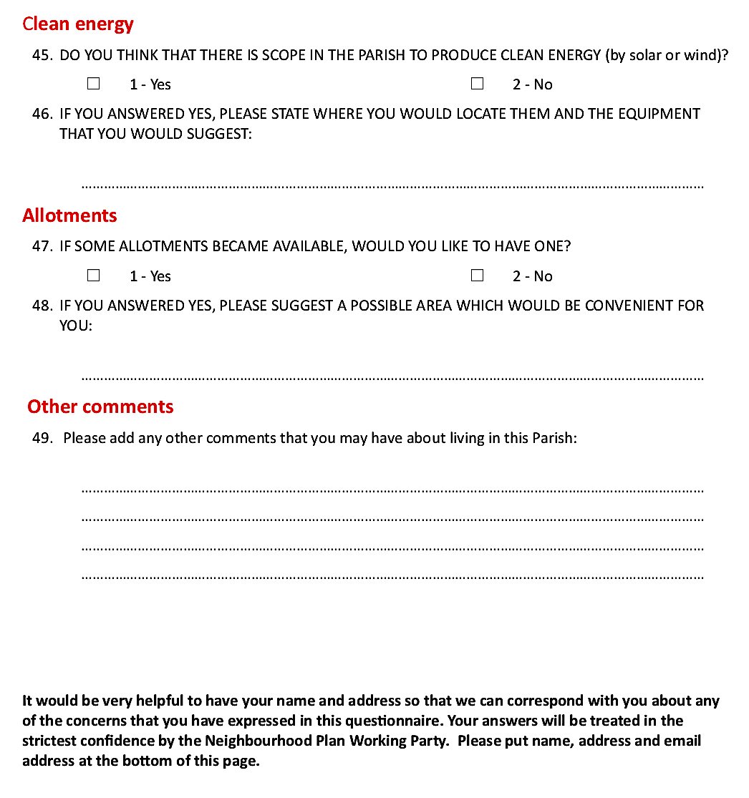

Appendix 11
Questionnaire 2A report (November 2017)

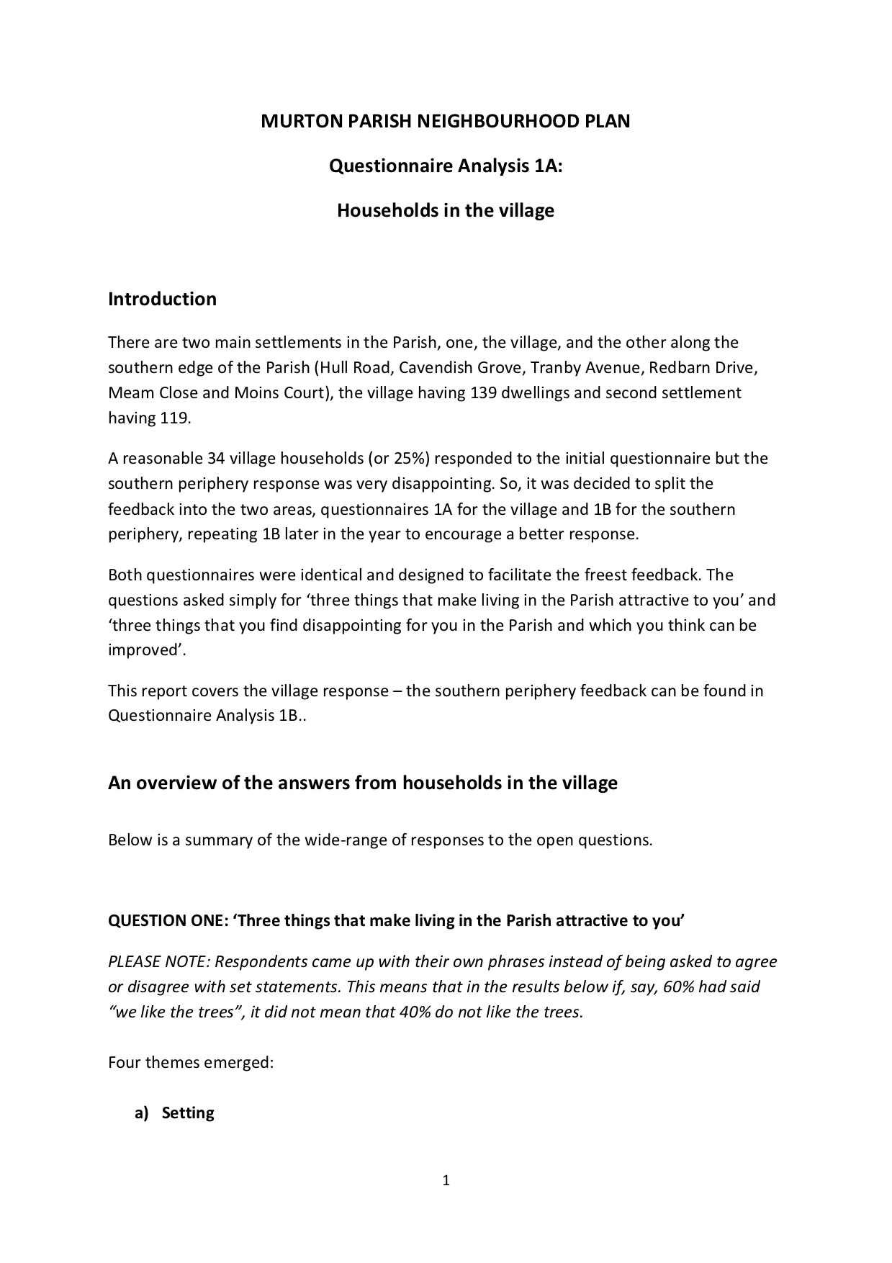
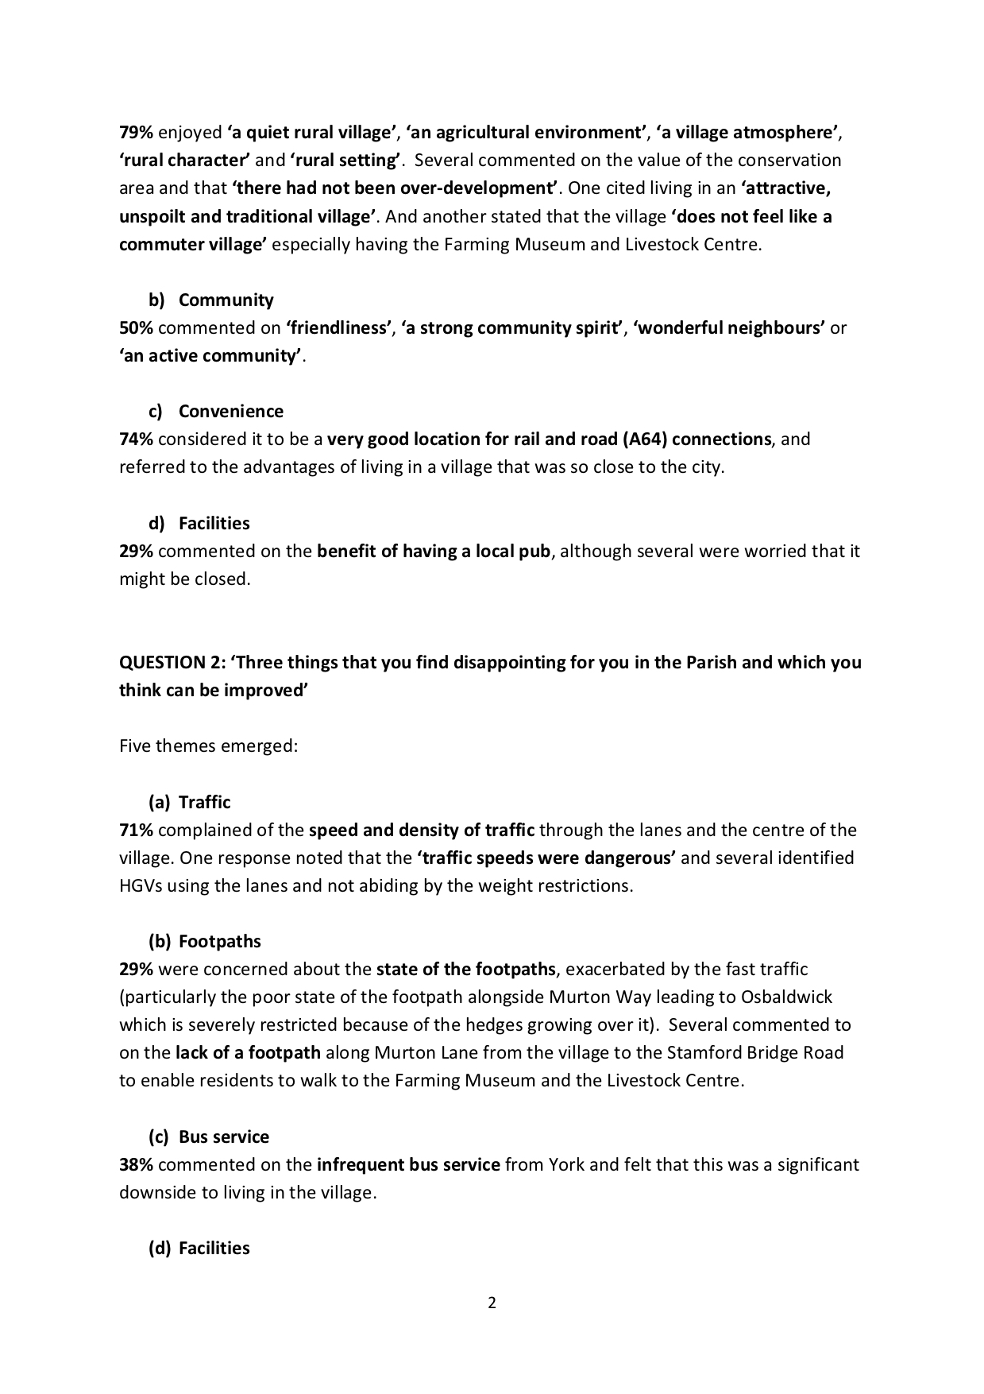

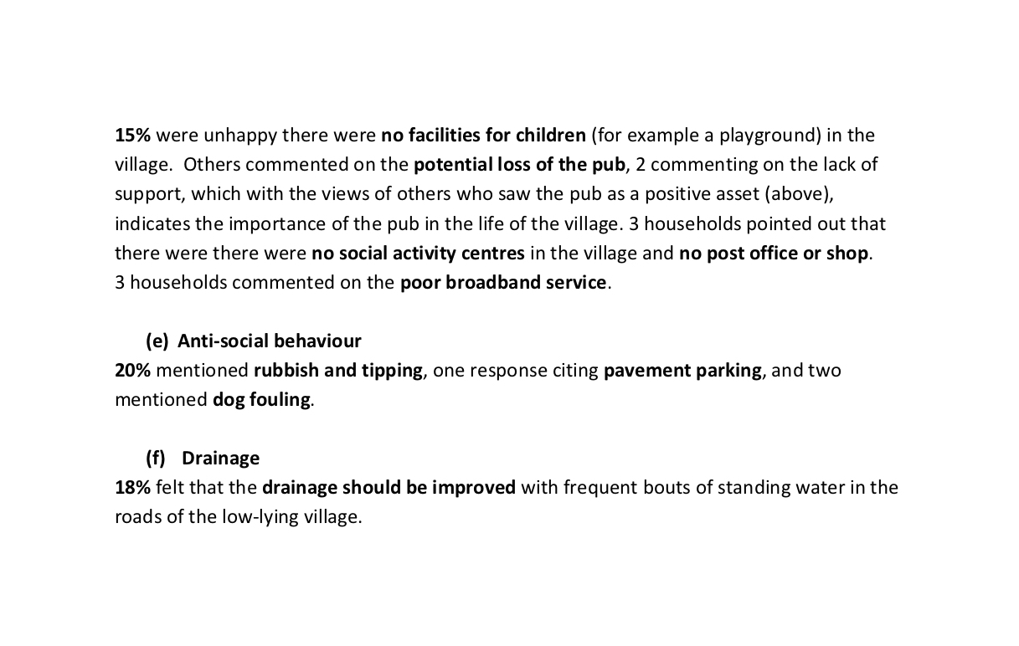

Appendix 12

Letter to residents from the Chairman of Murton Parish Council (February 2018)

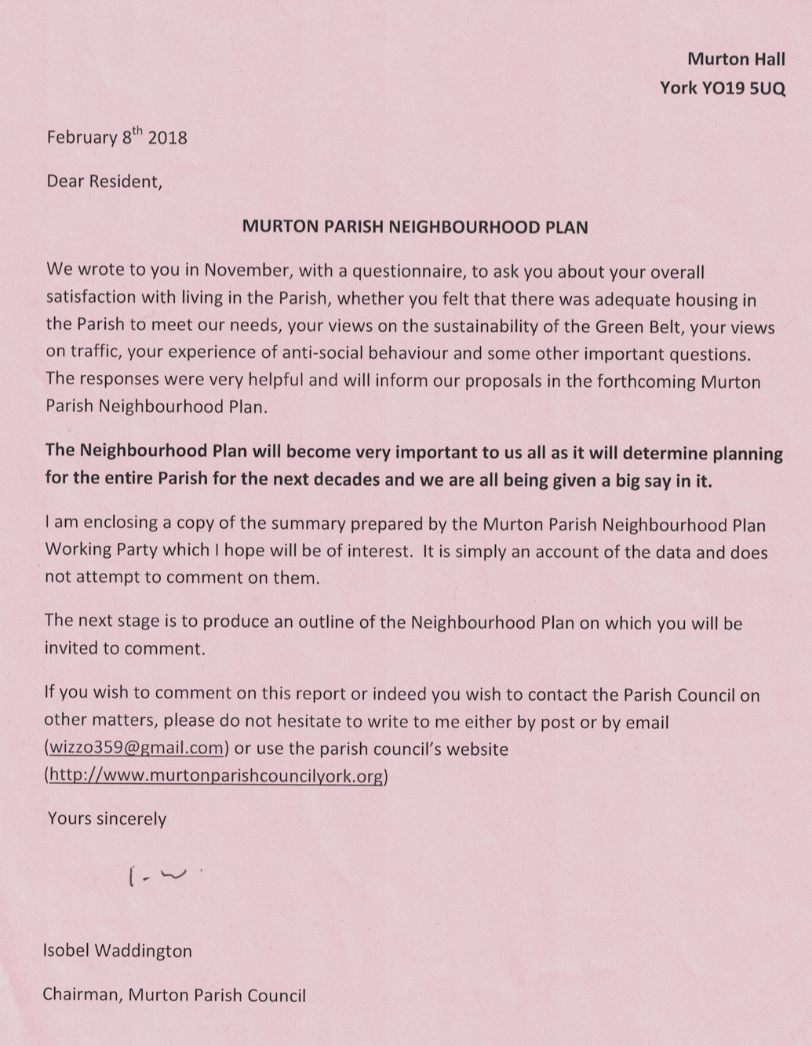

Appendix 13
Questionnaire 2B report (January 2018)

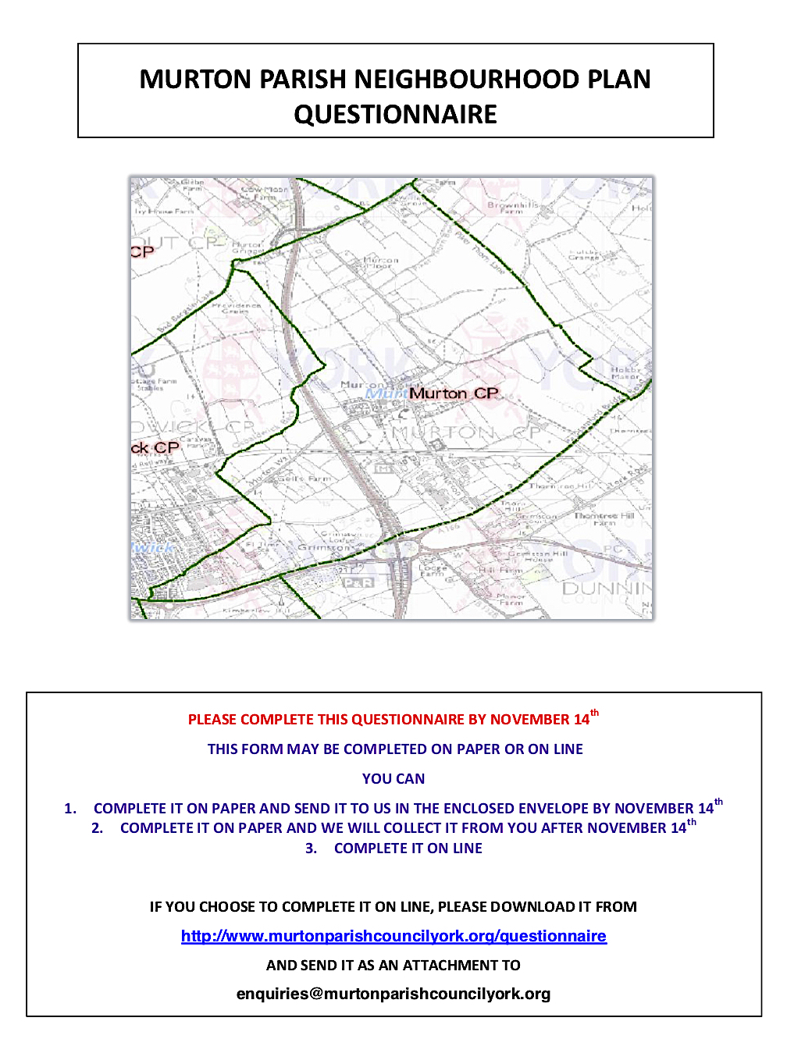

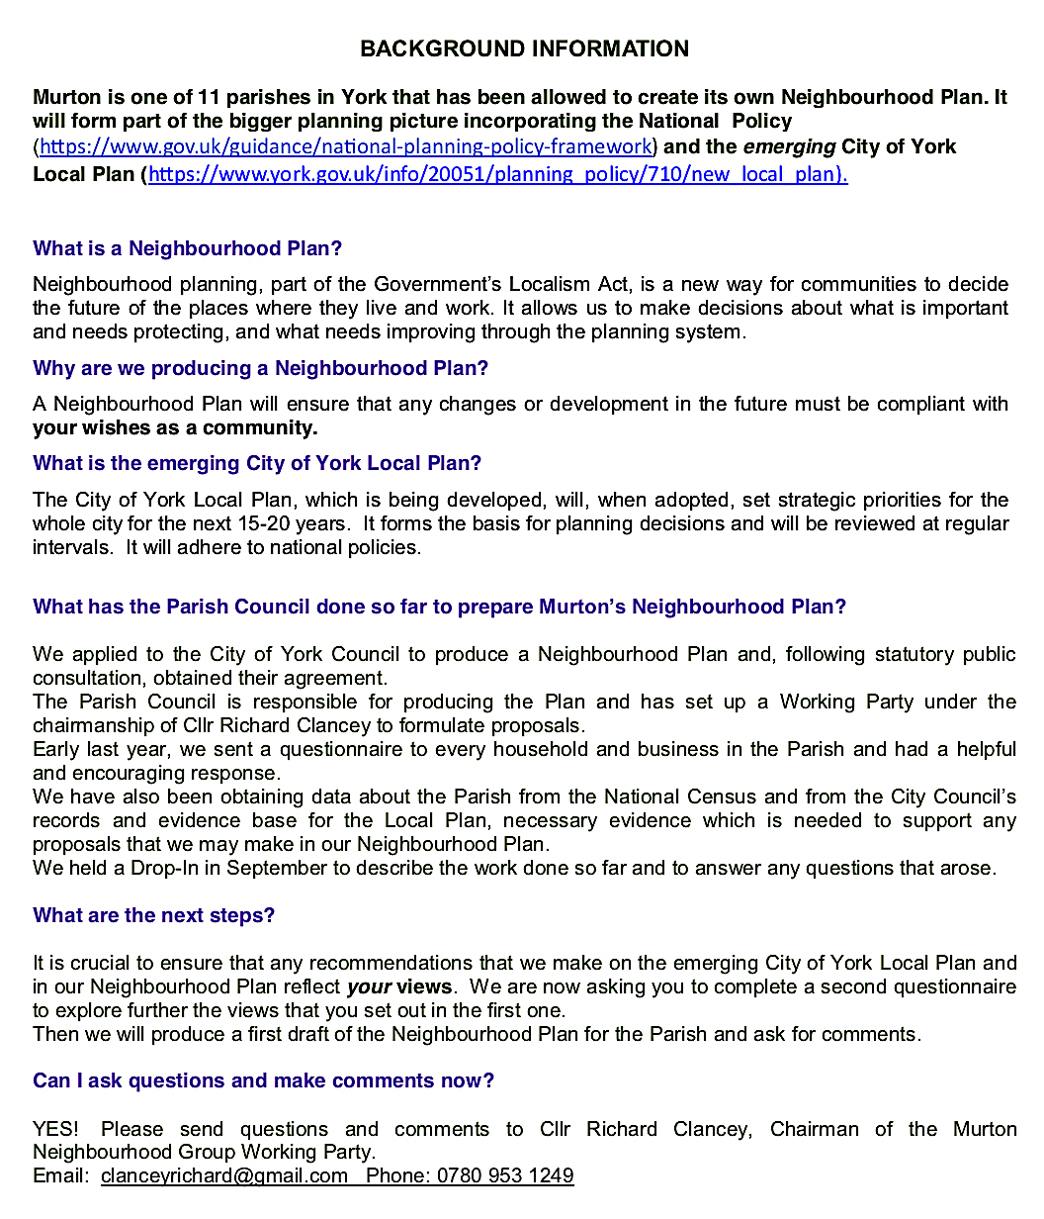

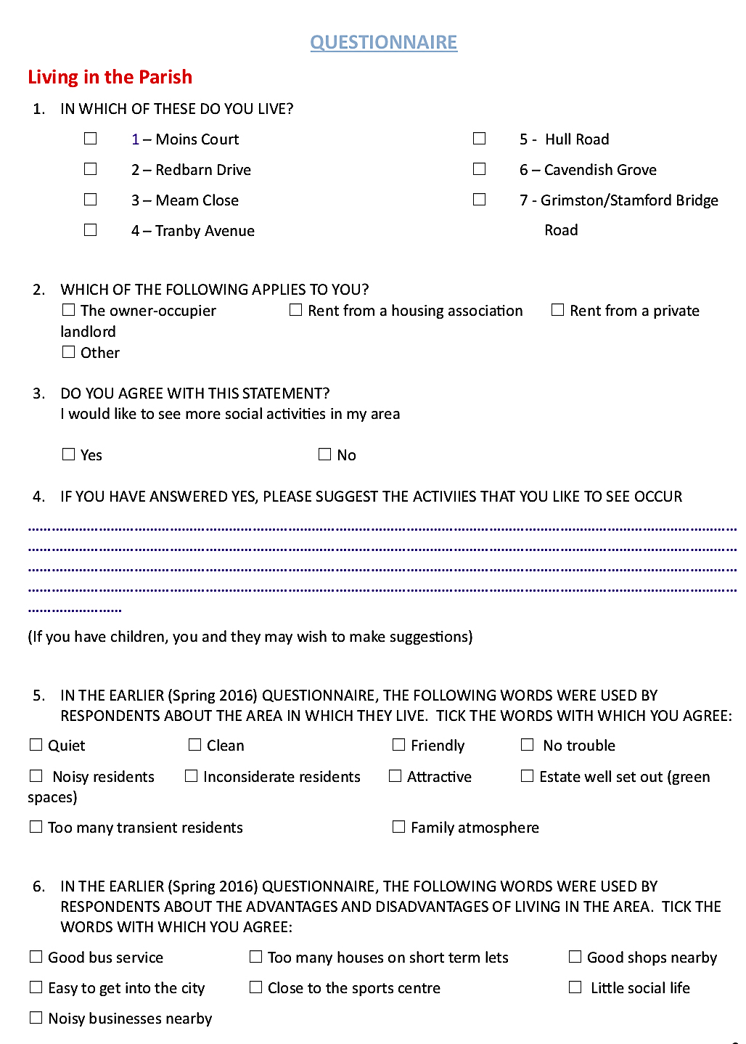

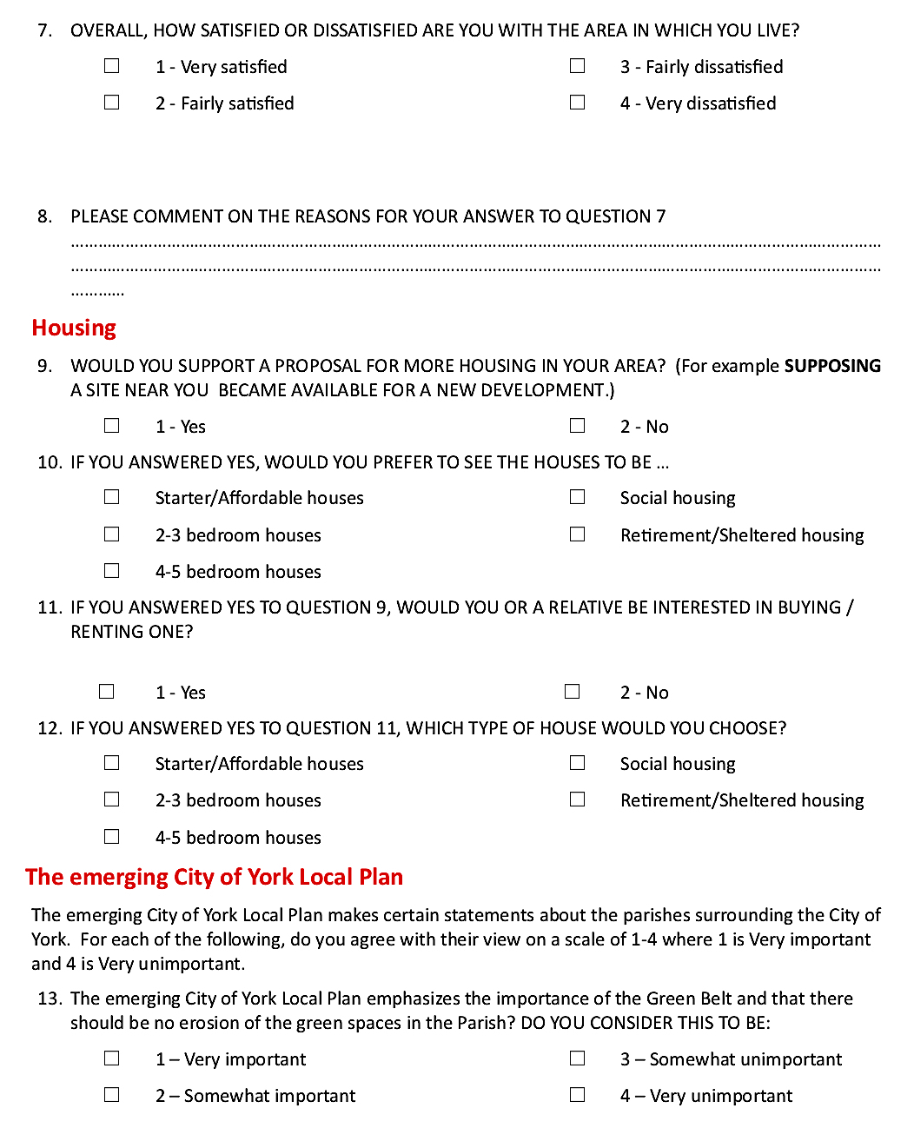

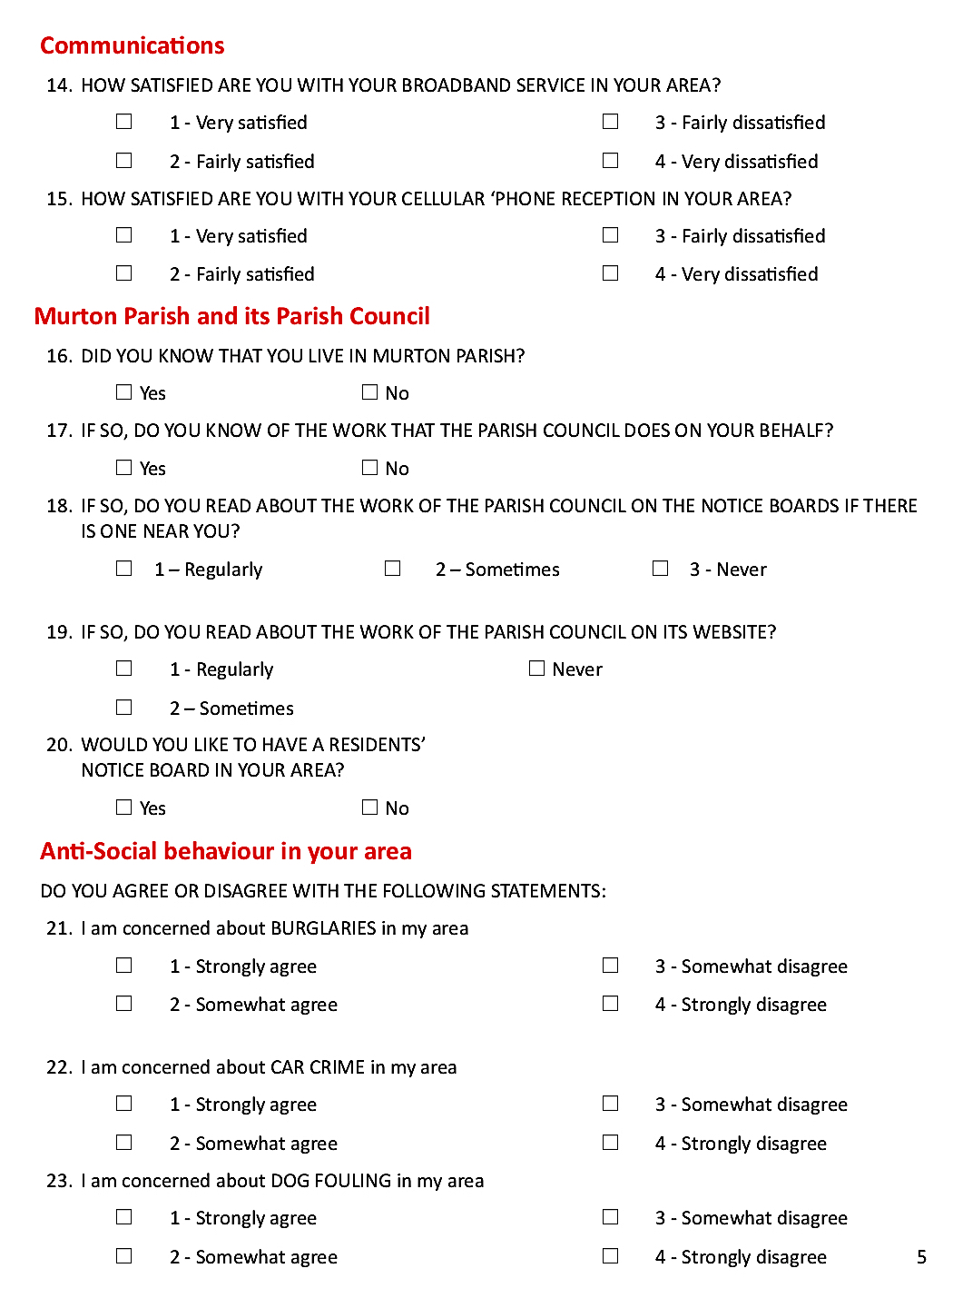

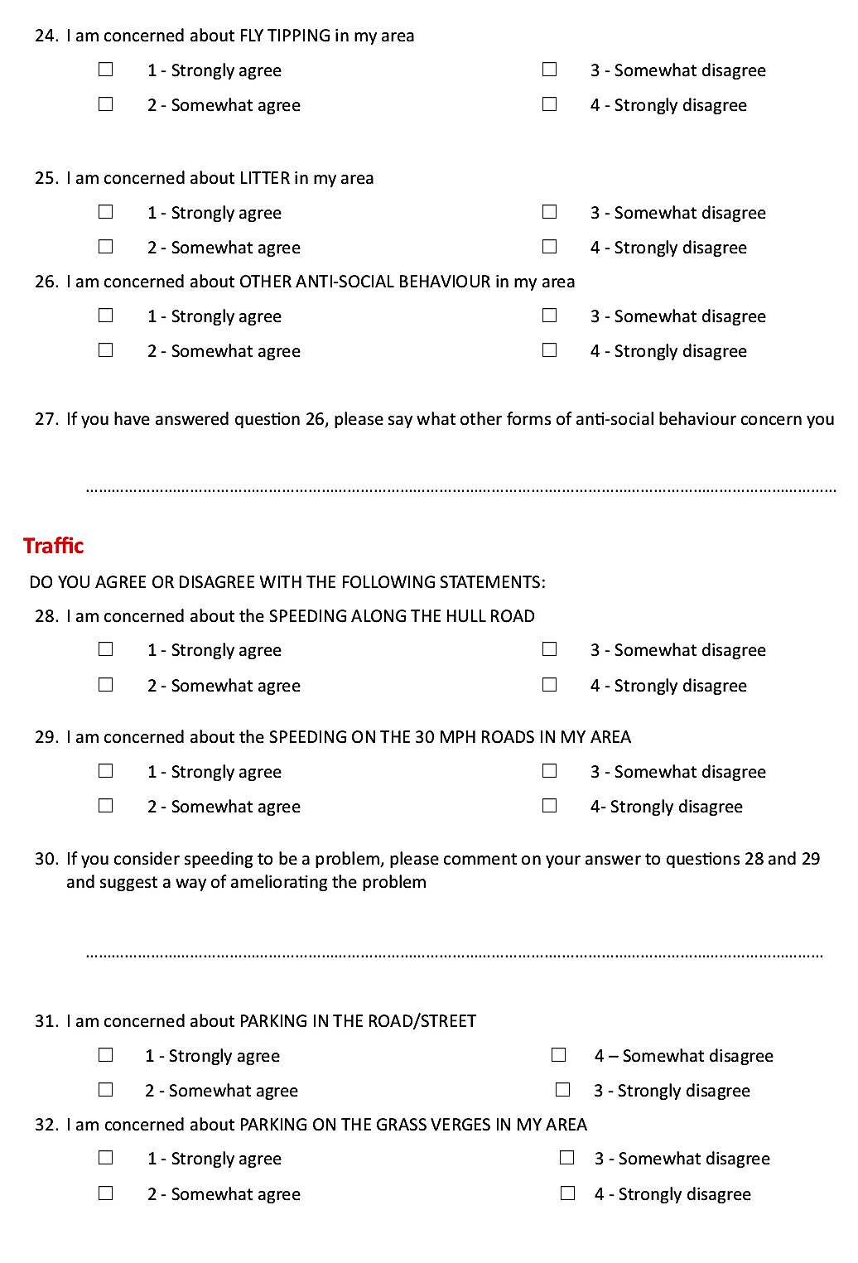

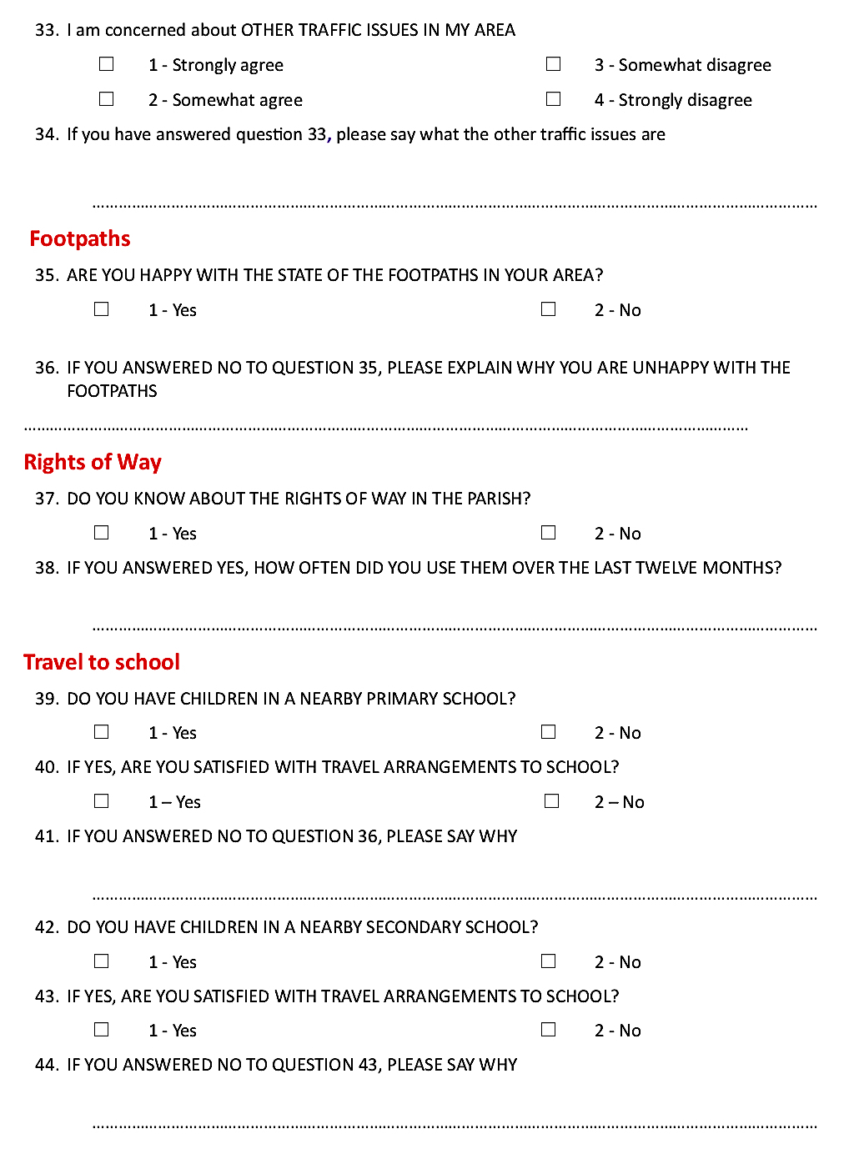

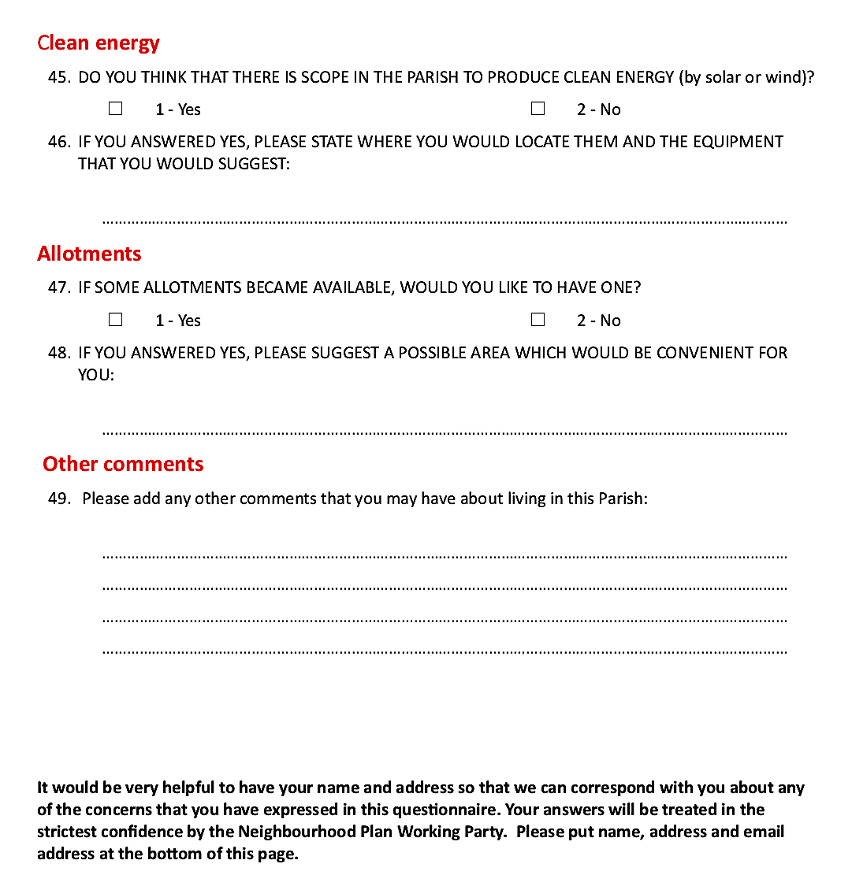

Appendix 14
Letter to businesses from the Chairman of Murton Parish Council Neighborhood Plan Working Party (January 2016)

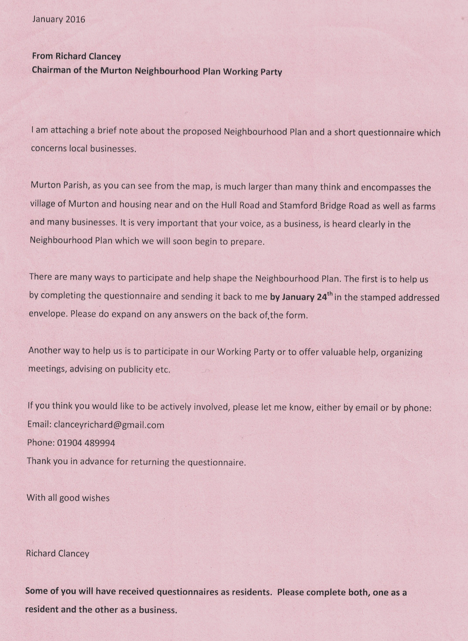

Appendix 15
Questionnaire 1C to businesses (January 2016)

MURTON PARISH COUNCIL
Questionnaire 1C : January 2016
We would be grateful if you would complete this brief questionnaire for your business.
- Where is your business?
A In or near the Murton Business Park
B Moor Lane
C In your own home
D Other

- State briefly the main business that is carried on

- Name three things about being in the Parish that is good for your business.
(i)

(ii)
(iii).

- Name three things that you find disappointing for your business and which you think can be improved.
(i).
(ii)
(iii)

Please amplify your answers on the back of the form. We will collect this questionnaire from your premises on January 24th. Thank you.

Appendix 16
Questionnaire 1C report

MURTON PARISH NEIGHBOURHOOD PLAN
Questionnaire Analysis 1C:
Businesses

Introduction
There is a diverse portfolio of businesses in the Parish. Of these, farming has played a pivotal role for centuries and continues to do so, both commercially and as a key contributor to the broader living experience valued by residents.

Not surprisingly, many of the other businesses are related in some way to agriculture, but leisure, retail, food processing and recycling are also represented, along with several well-established home-based entrepreneurial businesses. All these activities provide employment, taxes and support to the regional and national economies.

A full list of business types is at the end of this report.

Business locations

Commercial activity occurs broadly in three areas within the Parish:
Area 1 Murton Business Park, adjacent to the York-Stamford Bridge Road (A166) and the area close by;
Area 2 An area along the Hull Road;
Area 3 Moor Lane and Bad Bargain Lane.

The businesses in Areas 1 and 3 are physically separate from the two settlements but Area 2 is close to housing along the southern boundary of the Parish.

Most of the remaining non-residential land is used for farming.

Home-based businesses
Murton has a growing number of people working and running businesses from their own homes (reflecting employment trends across the UK). These include journalism, as well as livery stables and two animal breeding establishments, one for horses and the other for dogs, both with national recognition.

An overview of the answers from businesses

The business questionnaire asked for ‘three things in the Parish that are good for your business’ and ‘three things that you find disappointing for your business’.

Of the 50 questionnaires distributed, 12 were returned (24%) but with a useful cross-section stretching from four of the largest employers to three who worked at home.

QUESTION ONE: ‘Three things in the Parish that are good for your business’
Location emerged as the overriding advantage. 75% commented on the ready access to the national road system via the A64 and the closeness to the main national rail system. The impression given is that location is not just an advantage but crucial to business operations.

25% specifically cited Proximity to other businesses in Murton as an advantage, with three saying that the location was ‘good for business’.

One mentioned that the rural environment was important to the business and another commented on ‘the pleasant area’.

QUESTION 2: ‘Three things in the Parish that you find disappointing for your business’

25% cited speed of traffic as an issue.

42% complained of the poor broadband service

Other
There was a wide range of comments about the lack of some facilities, including the lack of a nearby post box and a poor bus service. Also mentioned were fly-tipping, the poor state of some hedges and problems with drainage.

Types of business in the Parish

Businesses relating to agriculture include

- William Thompson (York) Ltd, part of the BATA Group and one of the largest animal feed companies in the North-East, and at which there is a Country Store (Area 1)
- Holmefield Farm Services, a veterinary service and animal food supplier (Area 1)
- York Auction (Livestock) Centre which serves farmers over a wide area of Yorkshire and further afield (Area 1)
- Yorkshire Handlers which deals with agricultural machinery (Area 1)
- The ABP Food Group, a major international meat processing company (Area 1)

There are also some number of specialised businesses which include:
- L. Clancey and Sons, an important regional recycling centre and a family business for over 150 years (Area 1)
- Trustspan, a national timber engineering company (Area 1)
- A host of small companies, several of which are specialist car maintenance companies with high expertise (Area 1)
- A small group of businesses at Moor Lane Farm (Area 3)

There is a diverse mix of businesses essentially for leisure and retail, including:
- The York Auction Centre with a wide sale range including farm machinery, horses and other livestock including rare breeds, cars and antiques. It also holds very successful Farmers’ Markets and Sunday car boot sales (Area 1)
- Stephenson and Sons, a leading independent auctioneer in Yorkshire, a company that is over 140 years old (Area 1)
- A national superstore for DIY goods (Area 2)
- An independent petrol station with a substantial convenience store (Area 2)
- The Yorkshire Museum of Farming and the Derwent Light Railway at Murton Station (Area 1)
- Moor Lane Farm, a member of the Caravan and Camping Club (Area 3)
- Beetle Bank Farm, an Open Farm and Education Centre (Area 3)
- Murton Grange: Self-catered holiday cottages (Area 3)

Appendix 17
An invitation to residents and businesses to discuss the Murton Parish Neighbourhood Plan at a Drop-in (September 2016)
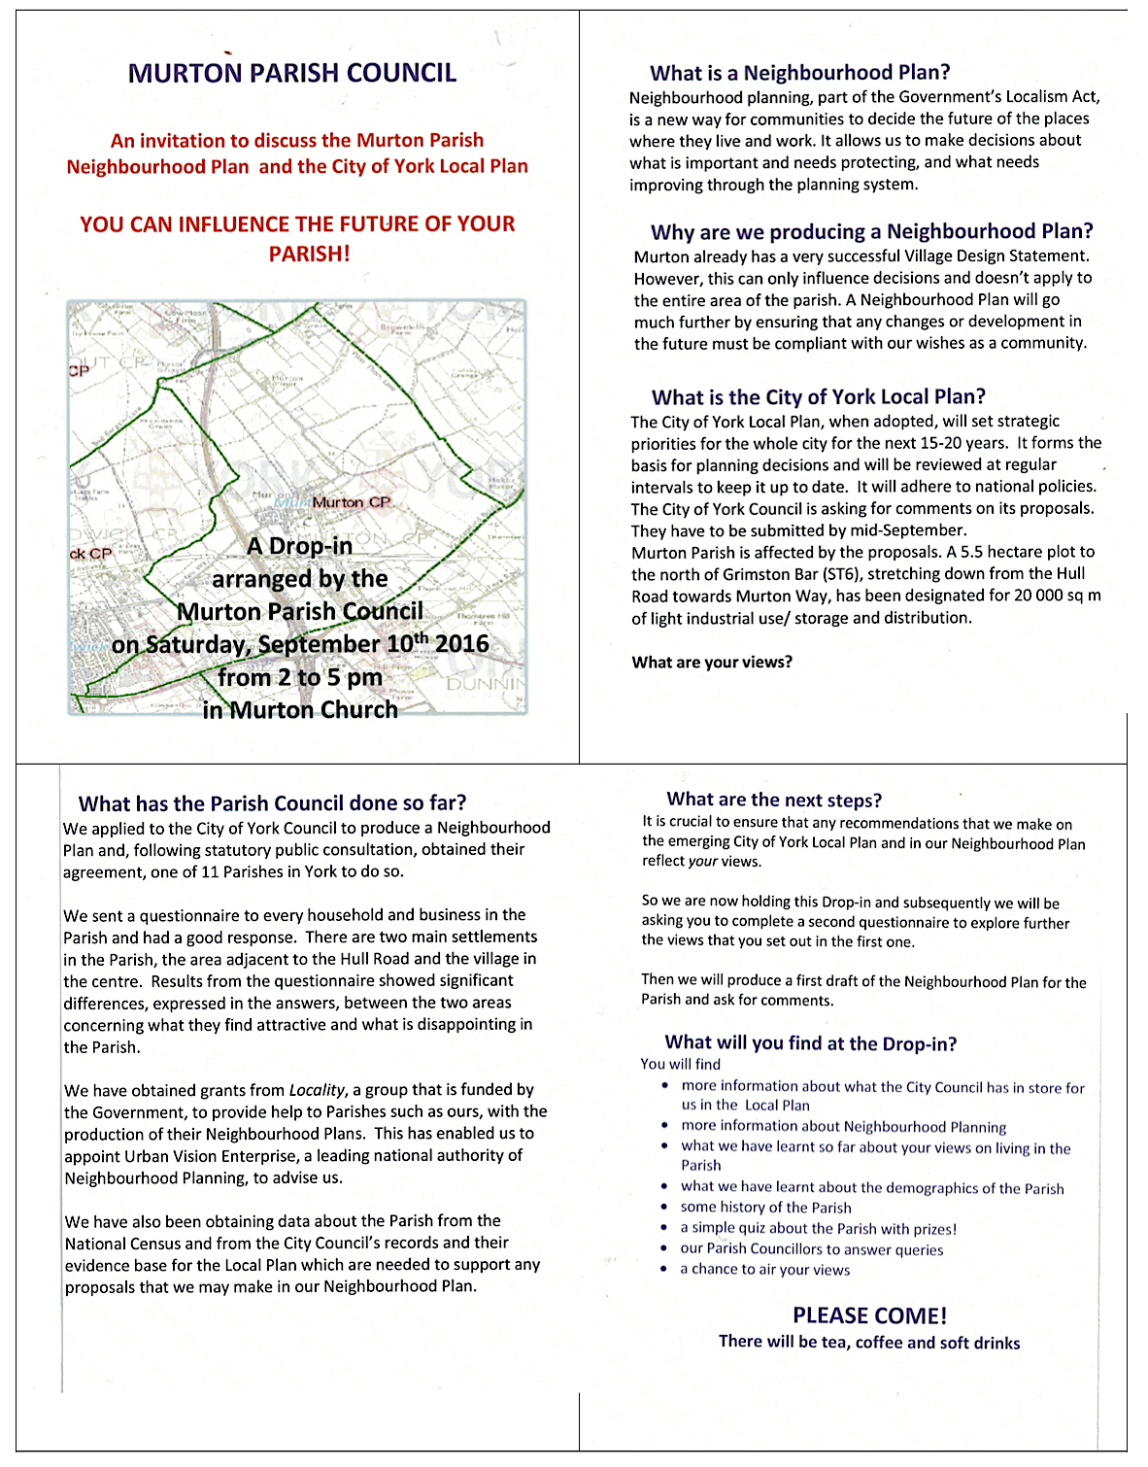

Appendix 18
A Newsletter to all households and businesses (August/September 2018)

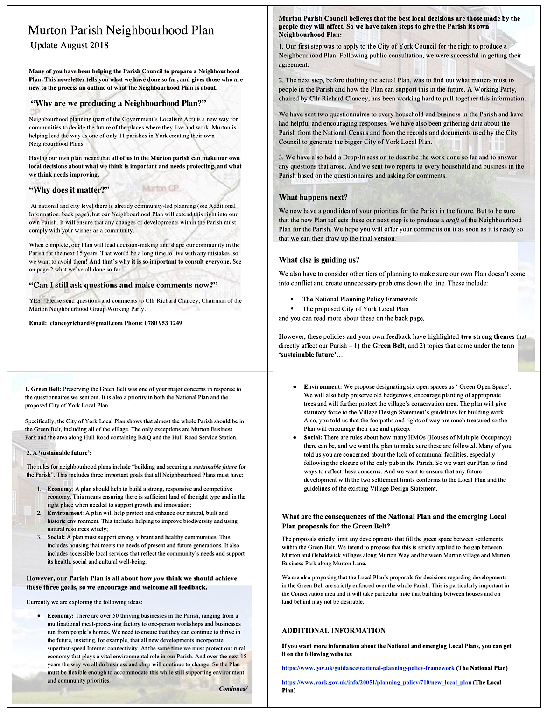

Appendix 19
Letter from the Chairmen of the Parish Council and the Neighbourhood Plan Working Party to households concerning the pre-submission consultation (April 2021)

MURTON PARISH COUNCIL

Murton Parish Neighbourhood Plan

April 2nd 2021
Dear Resident,

UPDATE: the future of our Parish

We are now very close to having our own Neighbourhood Plan – the guarantee that Murton people have more influence on the future of our Parish.

The Plan contains policies that are based on feedback given by residents and businesses, principally from the answers to the five questionnaires that were sent out over the last few years and from discussions.

Before we can submit the Plan to the City of York Council, we have one last big ‘ask’ – and we hope you will help.

All we need is for you to read the leaflet and tell us if there is anything there that concerns you. Your comments will be reflected in the final version that we submit.

N.B. The Plan has to be written in a formal style for legal clarity and we hope you can fight your way through any jargon - but do ask if anything is not clear.

It’s important that Murton’s future is shaped by its community, and this is another chance for you to contribute to this. So please get involved and help us to produce a document which really will then be OUR PLAN.

Isobel Waddington
Chairman, Murton Parish Council

Richard Clancey
Chairman, Murton Parish Neighbourhood Plan Working Party

USEFUL INFORMATION

What is the enclosed leaflet?
It is a summary of what will be in the Neighbourhood Plan that we will submit to the City of York Council. It also contains some explanatory information about the process.

Can I read the WHOLE draft plan?
Yes. You can read the complete Plan on our specially constructed website:

https://murtonneighbourhoodplan.org.uk/#content

If you prefer to study the Plan as a paper version, we have made arrangements for it to be available at the Yorkshire Museum of Farming, the City Library and at Tang Hall Library. For further details, please ask the Clerk to the Parish Council, Alastair McFarlane (01904 481306), or email him at murtonyorkparishclerk@yahoo.com

How can I comment on the draft Plan?
Enclosed with the leaflet is a request for comments and instructions on how to send them to us, either by hand or by email.

We really need your opinions, so please respond by May 18th

What happens next?
When we have had all the feedback, we will make final revisions to the draft Plan and submit it to City of York Council (CYC):

1. CYC makes sure the Plan fits with the Local Plan, and then sends it to an independent examiner to check it against national guidelines
2. If it passes these tests, the Plan is then sent back for a referendum vote in
the Parish. A simple majority turns the Plan into a statutory and binding
document.

Appendix 20
Letter from the Chairmen of the Parish Council and the Neighbourhood Plan Working Party to businesses concerning the pre-submission consultation (April 2021)

MURTON PARISH COUNCIL

Murton Parish Neighbourhood Plan

April 2nd 2021

Dear Colleague

We are now very close to having our own Neighbourhood Plan – the guarantee that Murton residents and businesses have more influence on the future of our Parish.

The current version of the Plan contains policies that are all based on feedback given by residents and businesses, principally from the answers to the five questionnaires that were sent out over the last few years and from discussions.

Before we can submit the plan to the City of York Council, we have one last big ‘ask’ – and we hope you will help.

All we need is for you to read the leaflet and tell us if there is anything there that concerns you. Your comments will be reflected in the final version that we submit.

N.B. The Plan has to be written in a formal style for legal clarity and we hope you can fight your way through any jargon - but do ask if anything is not clear.

The complete Plan is available on our specially prepared website and details on how to find it are given overleaf.

It’s important that Murton’s future is shaped by its community, and this is another chance for you to contribute to this. So please get involved and help us to produce a document which really will then be OUR PLAN.

Isobel Waddington
Chairman, Murton Parish Council

Richard Clancey
Chairman, Murton Parish Neighbourhood Plan Working Party

USEFUL INFORMATION

What is the enclosed leaflet?
It is a summary of what will be in the Neighbourhood Plan that we will submit to the City of York Council. It also contains some explanatory information about the process.

Can I read the WHOLE draft plan?
Yes. You can read the complete Plan on our website:

https://murtonneighbourhoodplan.org.uk/#content

If you prefer to study the Plan in a paper version, we have made arrangements for it to be available at the Yorkshire Museum of Farming, the City Library and at Tang Hall Library. For further details on how to arrange to read it, please ask the Clerk to the Parish Council, Alastair McFarlane, by emailing him at murtonyorkparishclerk@yahoo.com

You may be particularly interested in the following sections:

Section 4.5 Businesses and agriculture
Section 6.1 Introduction (Policies)
Section 6.2 Murton Parish and the Proposed City of York Green Belt
Section 6.5 Employment

How can I comment on the draft Plan?
Enclosed with the leaflet is a request for comments and instructions on how to send these to us.

We really need your opinions, so please respond by May 18th

What happens next?
Once we have heard your feedback, we make final revisions to the draft Plan and submit it to City of York Council (CYC). CYC will make sure that the Plan fits with their own Local Plan, and then will send it to an independent examiner to check it against national and legal guidelines.

If it passes these tests, there is a referendum vote in the Parish. A simple majority then turns the Plan into a statutory and binding document.

Appendix 21
Pamphlet outlining the Murton Parish Neighbourhood Plan: The pre-submission stage, for all households and businesses (April 2021)
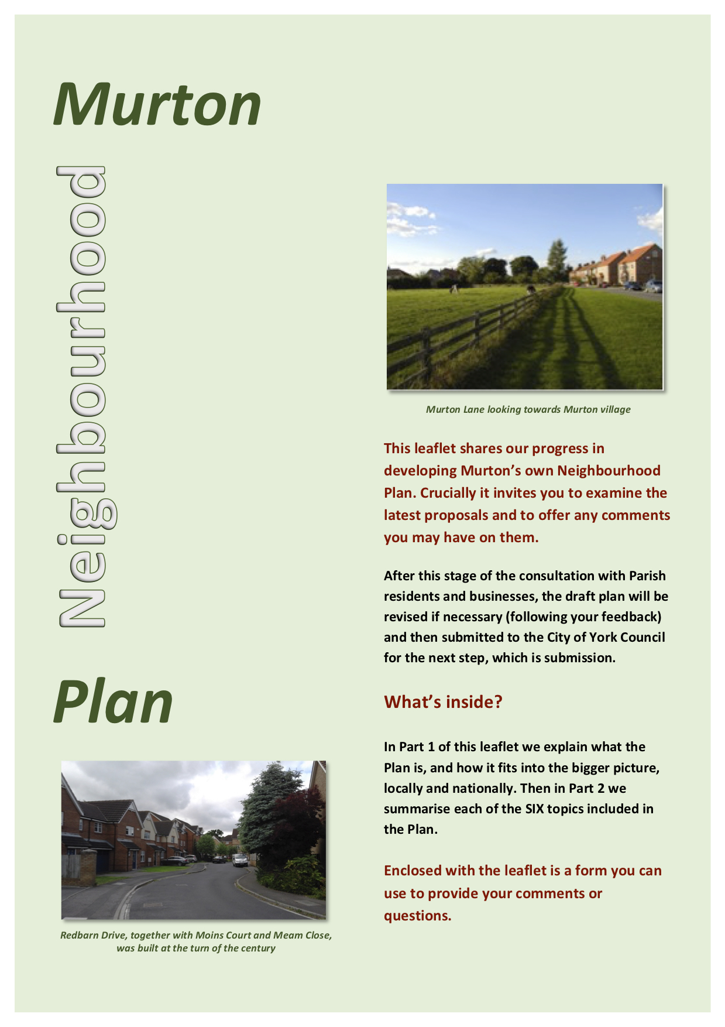
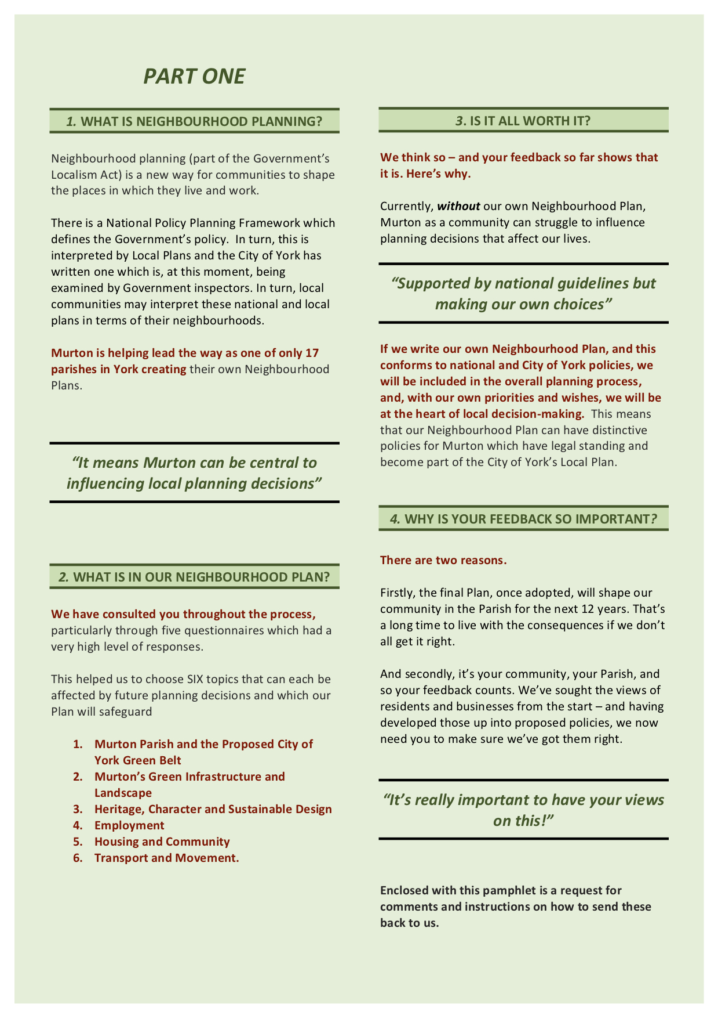

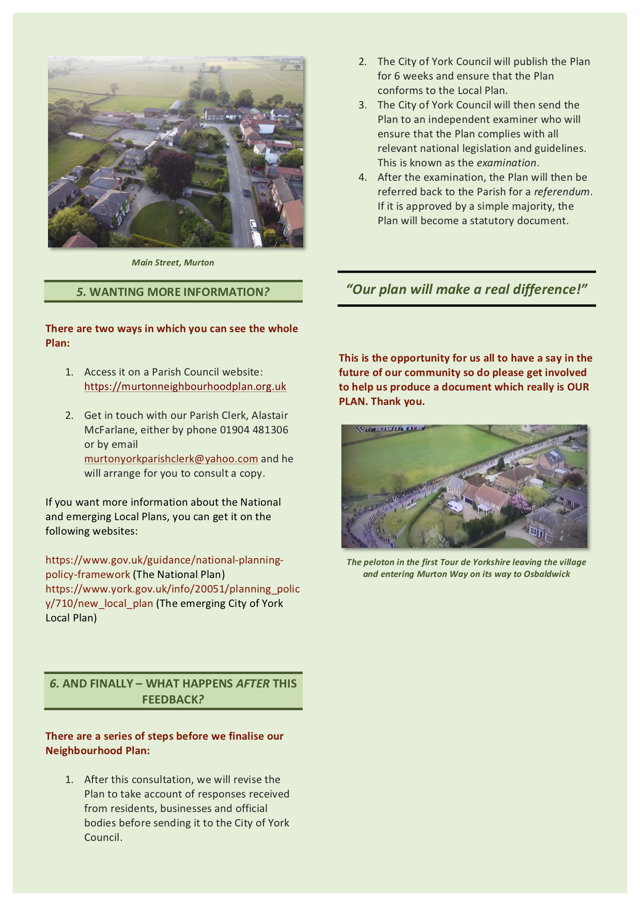

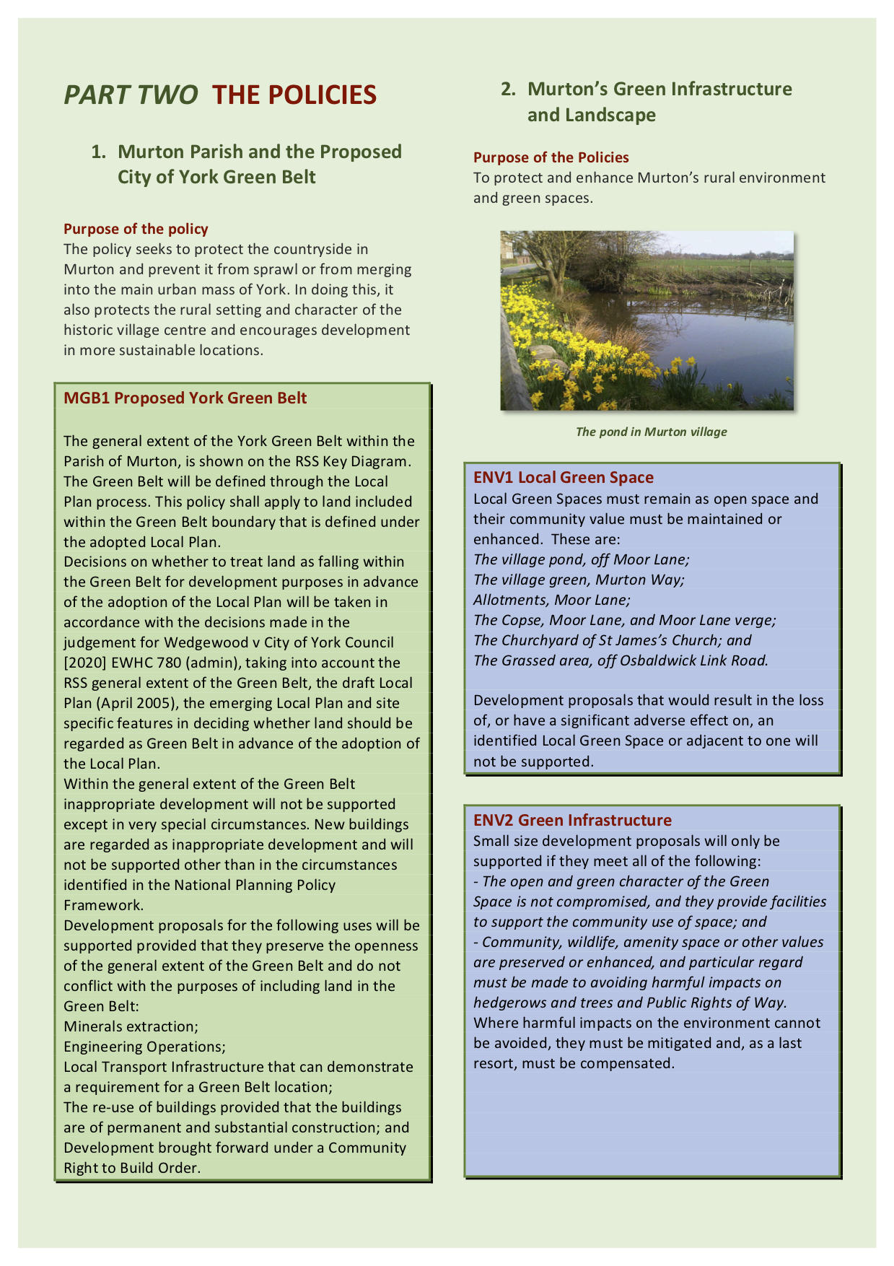

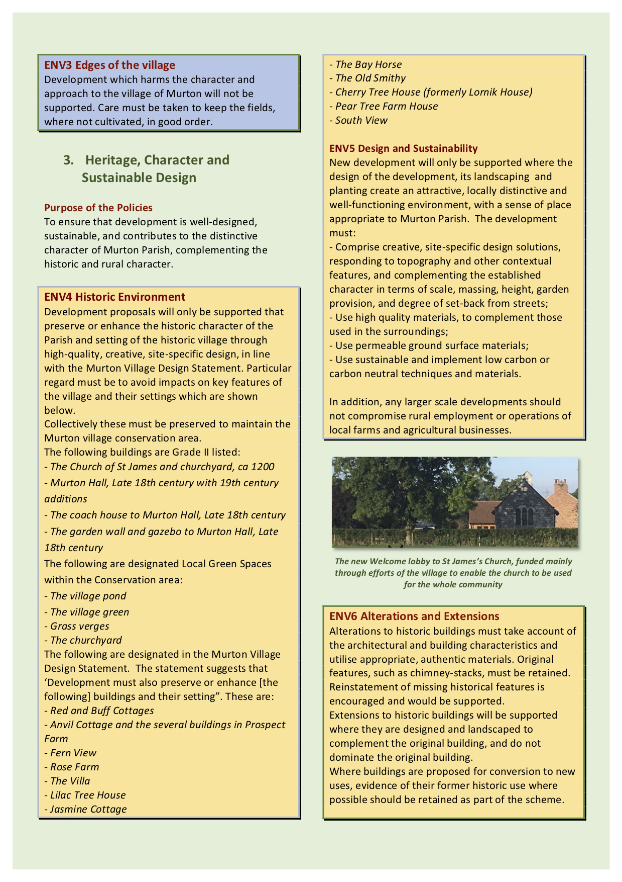

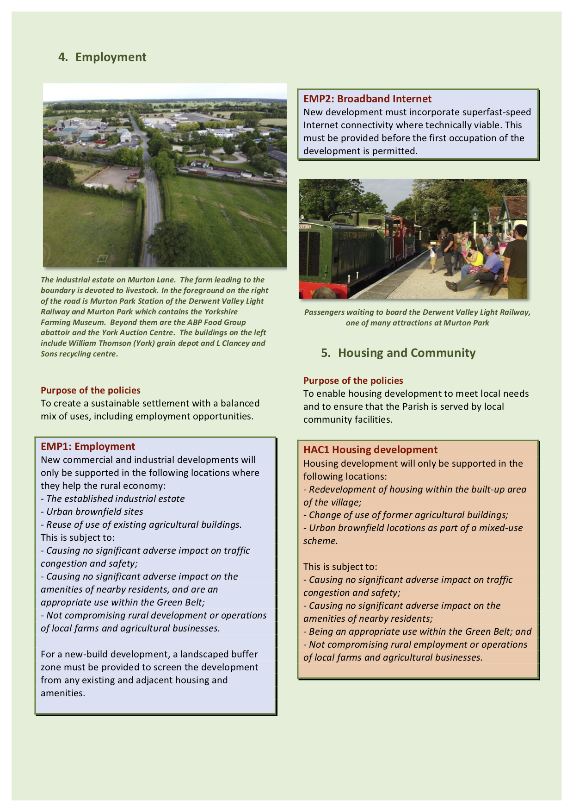

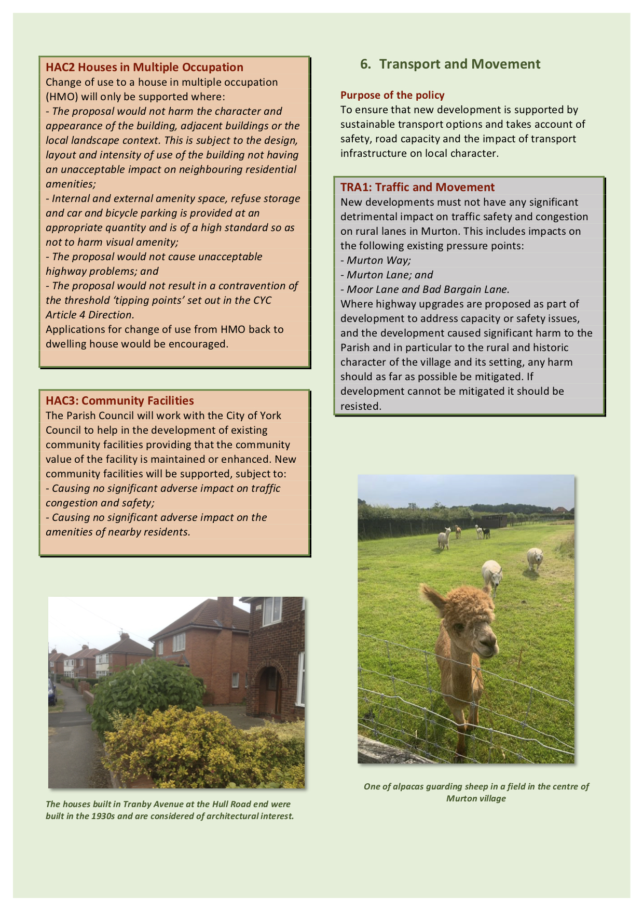

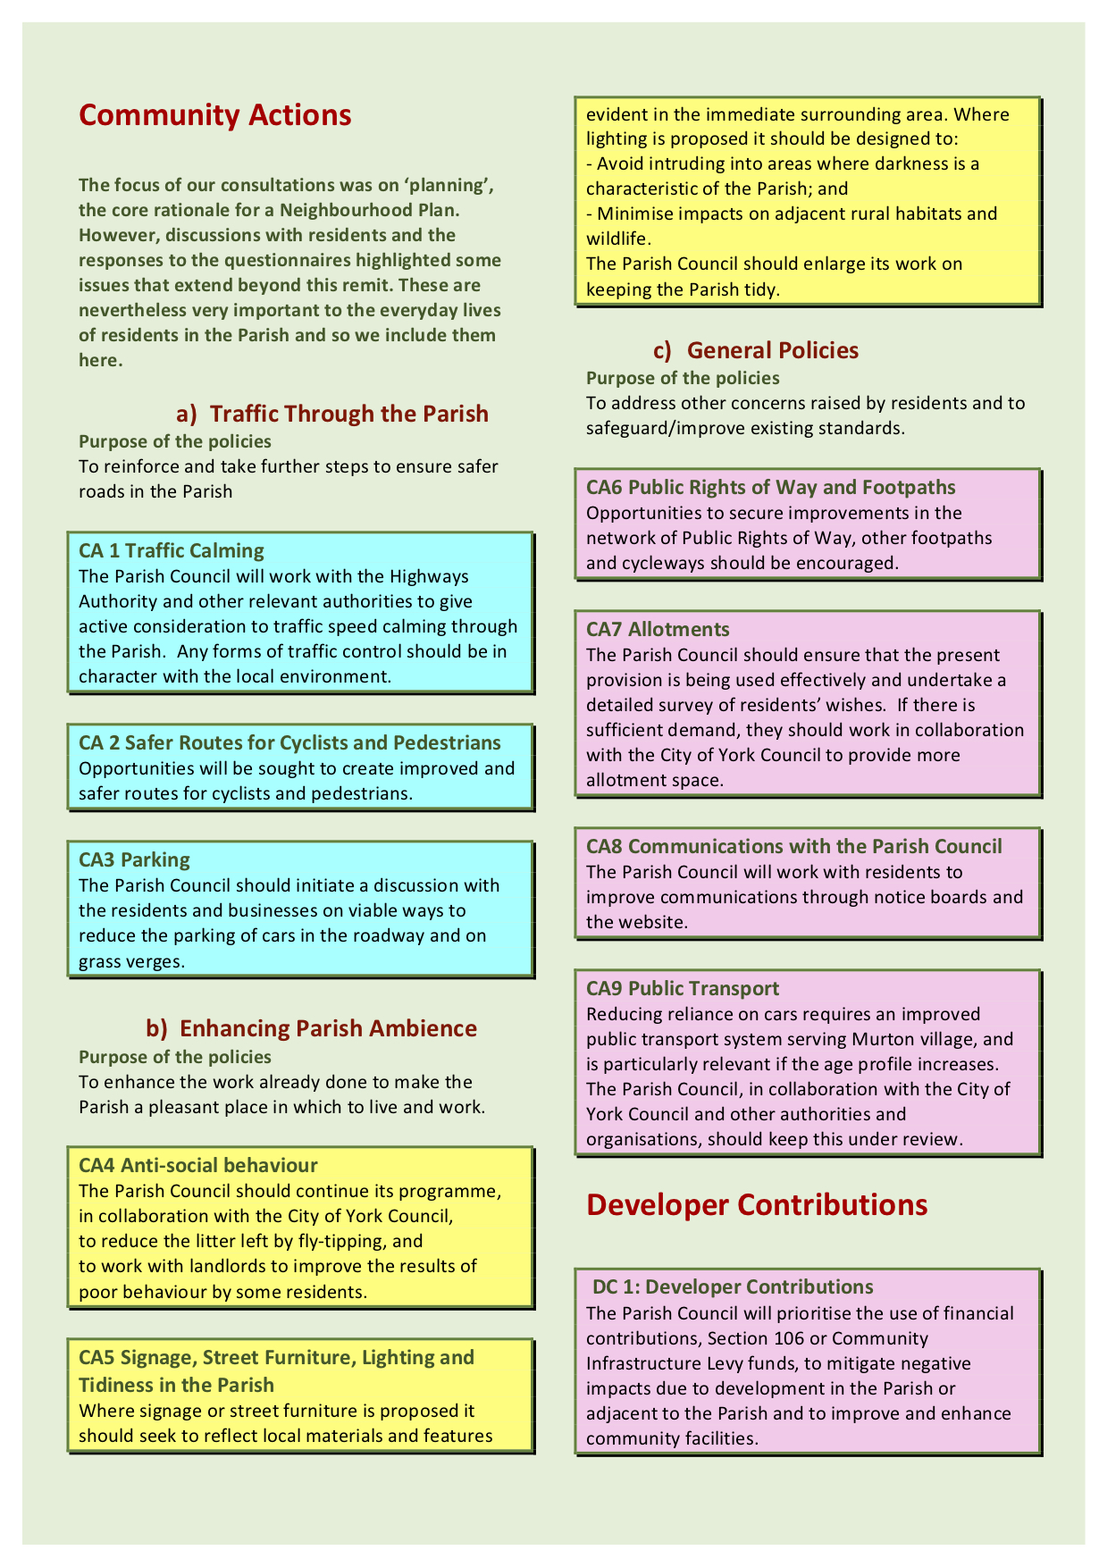

Appendix 22
A form which could be used for responses (April 2021)

MURTON PARISH NEIGHBOURHOOD PLAN
Public consultation April 2021
State whether you are commenting on the pamphlet or on the full Plan. If your comment relates to the Plan itself, please give the policy and/or paragraph numbers.
If you need more space, please use additional pieces of paper or download forms on
www.murtonneighbourhoodplan.org.uk

WRITE YOUR COMMENTS IN THE SPACE BELOW

PLEASE EMAIL THE FORM BY MAY 18th 2021 TO consultation@murtonneighbourhoodplan.org.uk
OR DELIVER IT TO KILBURN LODGE, MAIN STREET
If you wish to have a reply, please give your name and address on the f

Appendix 23
Email from the Clerk of Murton Parish Council to relevant organisations concerning the pre-submission consultation (April 2021)

From the Clerk of Murton Parish Council, York

Dear Sirs

Murton Parish Neighbourhood Plan
Murton Parish Council (Murton Parish is about 4 miles east of York, between the roads to Hull and to Malton) is preparing a Neighbourhood Plan.
It has reached the pre-submission stage and a public consultation is taking place between April 6th and May 18th 2021 prior to submission to the York City Council.
The City Council has asked us to alert you about the consultation and to invite you to send in any comments that you may wish to make.
The Neighbourhood Plan can be found on our Neighbourhood Plan website:
https://murtonneighbourhoodplan.org.uk/pre-submission.html#content
Please send your comments to the following address by May 18th
consultation@murtonneighbourhoodplan.org.uk
Please also give the page and paragraph numbers for each comment that you make.

Alastair McFarlane
Clerk, Murton Parish Council

Appendix 24
Organisations invited to comment on the
draft Murton Parish Neighbourhood Plan

Area Team North Yorkshire and Humber NHS Trust
British Gas
BT
Campaign to Protect Rural England
Churches Together York
City of York Council
Coal Authority
Dunnington Parish Council
EE Co
Environment Agency
Foss (2008) Internal Drainage Board
Heslington Parish Council
Heworth Without Parish Council
Highways England
Historic England
Holtby Parish Council
Homes and Communities Agency
Live Well York
National Grid
National Trust
Network Rail
Network Rail Infrastructure Limited
NHS
North Yorkshire Fire and rescue Services
North Yorkshire Police
Northern Gas
Northern Powergrid
Osbaldwick Parish Council
Talktalk PLC
Tees, Esk and Wear Valleys NHS Foundation Trust
The Coal Authority
Vale of York CCG
York Chamber of Commerce
York Civic Trust
York CVS
York Lesbian, Gay and Bisexual Forum
York Mosque
York Racial Equality Framework
York Retail Forum
York Teaching Hospital NHS Trust
Yorkshire Water

Appendix 25

Murton Parish Neighbourhood Plan:

Pre-submission Consultation comments and responses (December 2021)

No | Policy/Section/Paragraph | Respondent | Summary of comments | Response |  | Amendment to Plan
1 | General | ML1 | An extremely comprehensive neighbourhood plan. We have no further comments to add.
2 | General | SL1 | I have read the draft with enthusiasm and am very impressed by the amount of research and detail.
3 | General | SL1 | I feel that comments from people who do not know the detail of the parish might enable you to pre-empt criticisms from the official assessors. | We have consulted a leading planning consultant who gave us very detailed feedback and the Plan has evolved with constant feedback from the Forward Planning Group of the CYC. We have also consulted others who have been writing Neighbourhood Plans in the area.
4 | General | SL1 | When the decision to undertake a Neighborhood Plan was made I was skeptical because my understanding was that the purpose of such a plan was to determine the amount and type of future development in Murton parish with all the constraints that existed. The draft document has confirmed that. In terms of planning and development the draft reinforces the status quo and gives very little scope for developments of any kind except encouraging farming developments. Thus someone unfamiliar with Murton might criticize the document because of a perceived lack of opportunity for developments in the future. Would it be sensible to make a very explicit statement that the Neighborhood Plan Committee has very carefully considered future development options but has been unable to identify many because of the constraints? Such a statement can then stress how the parish already contributes significantly to retail, commercial, industrial employment and housing needs on the east side of York and that development plans just outside the parish boundary might be seen as relevant to the parish. | This is a very perceptive and important statement. We felt that we had done this but have obviously failed! |  | A new paragraph, 6.2.16.has been written.  In spite of the restrictions imposed by the Green Belt, new development proposals were nevertheless looked at very carefully. The succession of site allocation proposals for the emerging City of York Local Plan was examined together with other initiatives put forward in Working Party discussions. In each case, we were limited by the overarching proposal in the emerging City of York Local Plan that we are deemed to be in the Green Bely and that our role is explained in Paragraphs 4.6.2, 4.6.3 and 6.2.7.
5 | General | SL2 | First thanks to members of the Working Party and to everyone involved with the research for, and production of, the Neighborhood Plan for Murton. I like your emphasis on being ‘proactive’ rather than ‘reactive’, also the proposal that the Plan must have flexibility built in for future decision making’
6 | General | SL2 | I think that your gathering of data is important for setting the scene, giving context. Without accurate data, no policies.
7 | General | SL2 | I have appreciated your consultations with parishioners throughout the development of the policies for the Plan
8 | General | Osbaldwick Parish Council | Osbaldwick Parish Council fully supports the work of our neighbouring Murton Parish Council in producing this Neighbourhood Plan and is happy to support the well thought out document. It is hoped that the document is fully approved and becomes a material consideration within the CYC Planning system when the Murton Neighbourhood Plan is given the due regard and weight that the equally impressive VDS never was by CYC.
9 | General | City of York Council (CYC) | We appreciate the amount of hard work and dedication that the Neighbourhood Planning Group has put into this process to produce a locally representative document detailing the issues which affect Murton Parish. We also recognize the absence of an up-to-date adopted York Local Plan and the timing of the emerging Local Plan may have proved problematic for you and we appreciate work undertaken in this respect.  The pre-submission document is very thorough and covers a range of pertinent policies and community actions
10 | General | CYC | It would be useful if paragraph numbers could be added for all paragraphs for clarity in Sections 1-3. Sections 4-7 have paragraphs already numbered. | Agreed |  | Paragraph numbers added
11 | General | CYC | The pre-submission version usefully shows the evidence and data gathered as part of the Neighbourhood Plan process and how this has been used to form the basis of the policies. All of this information should be put into the Consultation Statement when the Submission Version of the Neighbourhood Plan is written. | Agreed. |  | A Consultation Statement has been written. This table forms a crucial part of it.
12 | General | CYC | The submission version of the Neighbourhood Plan will require a policies map to show the spatial elements of the policies – due to limited resourcing in the Forward Planning Team we will not be able to provide these maps. We recommend the Parish commission a company to map the data for you. | Agreed that the map(s) is (are) important. However, most of the policies are concerned with relatively small discrete areas of the Parish and attempting to put all the information on one map produced one that was difficult to follow. A series of maps brought together proved to be more informative. |  | New Figures 6.1-6.5  have been drawn and are in Section 6.1. The subsequent figures in Section 6 have been renumbered.  The following paragraph has been added:  6.1.6 Although maps in Section 4 show the locations of the buildings and other points of interest which are mentioned specifically in the Policies in this Section, for ease of reading, these have been redisplayed below, Figures 6.1-6.5
13 | General | CYC | Copyright is required for all CYC Maps as follows: “Based upon the Ordnance Survey mapping with the permission of the Controller of Her Majesty's Stationery Office, Crown Copyright. Unauthorized reproduction infringes Crown copyright and may lead to prosecution or civil proceedings. City of York Council, License No. 1000 20818. Prepared by Forward Planning Team, 2021” | Agreed. |  | Acknowledgement is given below each map as requested.
14 | General | CYC | We would recommend a general check throughout the plan parts of the plan are correct and that to make sure the references cross referencing to different the web addresses noted as footnotes work correctly and there are not any missing links. | Agreed |  | The check has been made.
15 | MY1 | General | Confident there has not been anything omitted. Sections clear to read and understand. The plan is easy to read without being overwhelmed by its content.  Thorough in its detail and easy to locate a particular item.
16 | MV1 | Foreword | New buildings and community facilities should include a village hall with car parking, sports field/children’s playground and car park to reduce street parking | Policy HAC3 Community facilities gives the Parish encouragement to develop community facilities for the whole Parish. Paragraphs 6.6.24 to 6.6.28 outline the rationale and evidence for the Policy and paragraph 6.6.24 an interpretation. |  | No change in the Plan but the suggestions have been given to the Parish Council
17 | CYC | Foreword | The footnote web address is New Local Plan Examination-City of York Council | Agreed |  | A later reference has been given
18 | CYC | Section 2 | Amend Figure 2.1 legend to July 23rd 2015 | Agreed |  | Done
19 | CYC | Section 2 | Amend thus:  2. …..conforms to the Neighborhood Plan Regulations and then publish the Plan for 6 weeks.  4. After the examination, the City of York Council Executive members will decide if they agree with the Examiners Recommendations and whether the Plan should proceed to Referendum. If it is approved….. | Agreed |  | Done  Section 2.8  Section 2.10
20 | SL1 | Section 3 | The aims are clear and sensible from the point of view of local needs and desires and the policies all seem very relevant in relation to the needs of the people of Murton
21 | SL1 | Para 4.5.4, 4.5.5 | I was pleased to see stress put on the importance of agriculture to the local community and the environment of the village and civil parish. This accords with Design guidelines, Village Design Statement.  I feel that the argument about the importance of farming should be strengthened.  The description of the focus of farming is outdated. The description of current farming activity in 4.6.7 is more accurate. It would be good to have a clearer statement of the organization of farming in the parish and its products | We are in total agreement with the importance of agriculture in the Parish. Farming is indeed very important to its well-being. Paragraphs 4.5.1 (‘pivotal role’ and 4.5.4 (‘….profound environmental consequences…..’ and ‘ …..Integral to the overall pleasure…..’) we feel do stress this point.  We agree that the description of farming in Paragraph 4.6.7 taken from the VDS is now outdated with its description of farming. |  | Paragraph 4.5.4 has been extensively rewritten. The design statement 3 in the VDS has been added and the description of farming updated.  As the description of farming in Paragraph 4.6.7 is part of a quotation, we cannot change the wording but will delete the words from ‘Current farming activity…….and the survival of…..’  Paragraph 4.6.4 now reads:  4.6.4 Much of the Parish’s 340 hectares is a patchwork of low lying pasture land, at present devoted largely to sheep, often delineated…..
22 | CYC | Para 4.6.2 | Recommendation: The RSS policy references are updated thus  The Neighbourhood Plan needs to be in general conformity with strategic policies in the Development Plan. In this case, these are the saved policies YH9 and Y1 of The Yorkshire…….. | Agreed |  | Recommendation accepted
23 | MV1 | Para 4.6.9 | I did not know that there were any allotments. Surely water butts could be used until there is a water supply laid. Safe access is needed. Grants available? | The first recorded instance of Parish Land being let is March 1896. Various pieces of land were subsequently let to different tenants over the years. However, the areas of land which we presently call the 'allotments' was formally agreed for letting under The Allotments Acts, 1908 to 1950, in 1969 |  | Suggestions have been forwarded to the Parish Council
24 | MV1 | Para 4.6.10 | Water table and flooding. On-street car parking prevents the cleaning of the gutters and drains; residents unaware that the drains are old and shallow and there is poor practice (e.g. cooking fat put down drains); impermeable materials used on verges, gardens, drives….Information pack for residents? | Agree |  | Suggestions have been forwarded to the Parish Council
25 | MV1 | Para 4.7.2 | Beetle Bank Farm has a café for visitors. The Auction Centre has a cafeteria, not a restaurant | Agree |  | Wording in paragraph 4.7.2 has been altered
26 | MV1 | Section 4,5 | List all businesses to show Murton is doing more than its fair share in providing jobs to local people and others | The problem is that some businesses are temporary, hiring the property they use.  Of the 54 current businesses, 14 are named.. |  | Added in Paragraph 4.5.6 Xandor Automotive which has a transport distribution facility for this international company
27 | MV1 | Para 4.7.4, 4.7.5 | Sustainability accreditation reduced by the large number of private car journeys as there is a very limited bus service.  Encourage car sharing. Electric points are needed.  Need green plans and encourage and facilitate mitigation of global warming.  Pragmatic approach to change in the conservation area. Houses where solar panels are not structurally suitable may have to consider using pvc windows or rendering.  More trees and rewilding. | Bus service is covered in Policy CA9.  There are already national guidelines for houses that are listed and houses in conservation areas  See Policies ENV1 and ENV2.See also paragraph 6.3.9 |  | See 80 below  This suggestion has been forwarded to the Parish Council  No change  No change
28 | Thompson’s of York | General; | The Murton Neighbourhood Plan is excellent. It covers all the aspects in which the community is built upon, and at the same time has captured what is required for the future. We fully support your plan and its development. It is always a difficult task balancing the needs of any society but with everyone’s help and cooperation, we see no reason why Murton will not continue to adapt to changing times at the same time as keeping its long and precious heritage and character. | It is very encouraging that one of the most important employers in the Parish thinks along these lines.
29 | SL1 | Section 4.2  and Section 6.2 | I would put more emphasis on the relatively unchanged nature of Town Street as it was long called. It would help to reproduce plans from 1796 to the present day in a juxtaposition way (perhaps 4 to a page) which would help to stress the case for conserving the core of the village. The Village Design Statement was held out as model for others partly through its use of maps and plans.  I would also make the point that there is distinctiveness about Murton being relatively unchanged compared with most villages which have been absorbed into the City of York. | The reproduction of the maps would be very helpful to the discussion.  Agreed |  | A double-page spread of 7 maps from 1796 to 2000 has been added in Section 4 with an explanatory sentence in a new Section 4.2.3.  See 59 below
30 | SL1 | Para 4.2.5 | The boundary between Murton and Grimston ran down the middle of the old turnpike road which is now the A1079 and A166. The property on the Murton side was always in the Murton Parish/Township and not in the Grimston Township. | Agreed |  | The sentence in Paragraph 4.2.6 has been altered.to  ……known as Grimston Bar (Figure 4.1, F) and three houses…..
31 | National Grid | General | There is an electrical substation in the Parish and the National Grid have land rights which prevents the erection of permanent/temporary buildings and structures, changes to existing ground levels, storage of material, etc. | This should be noted in the Neighbourhood Plan |  | Insert new para 4.5.9  Infrastructure  4.5.9 Among the infrastructure in the Parish which serve a wide area well beyond its boundaries are  (i) an electrical sub-station owned by the National Grid (Figures 4.4 and 4.5)  (ii) a 250 mm diameter public foul rising main and a 300 mm diameter public foul rising main crosses the Parish and is maintained by Yorkshire Water
32 | SL1 | Paras 4.5.4 – 4.5.8 | I was pleased to see the stress put on the importance of agriculture to the local community and the environment of the village and civil parish. This accords with the Design Guideline 3 of the VDS.  However, the argument of about the importance of farming should be strengthened.  The description of farming in Murton is outdated and is now on animal husbandry and the majority of land is used for grazing. It would be good to give the approximate sheep numbers and explain the conflicts between some human activity and sheep.  It would be good to have a clearer statement of the organization of farming in the Parish and its products. | Agreed  See 21 above.  Agreed. It is difficult to obtain numbers as they fluctuate widely. |  | VDS Design Guideline 3 is quoted on full in paragraph 4.5.4.  Sentence in Paragraph 4.5.4 altered to reflect comment. ‘The farming profile is agile, evolving to reflect market trends.  Much of today’s focus is now on animal husbandry, particularly sheep and some cattle and much of the land is used for grazing. You can read more about the farms under Environment and Green Belt below...
33 | CYC | Sections 4.6 and 6.2 | We welcome the sections on the Green Belt and how it reflects the high court judgement (Wedgewood v City of York Council v Christ Church Group [2020] EWHC 780 (Admin)).
34 | SL1 | Sections 4.6 and 6.2 | An excellent section, but the point could be made more strongly that the enforcement of the Green Belt would ensure land continues to be made available for farming, thus allowing the village remaining in a farming environment. Loss of land for whatever purpose reduces the viability of farming in the Parish. This point could also be made in paragraphs 4.6.2 and 4.6.3.and in Policy MGB1. | Agreed. |  | New Paragraph 6.2.14  6.2.14 Further the Policy ensures that land continues to be made available for farming, thus allowing the Parish to remain as a farming environment. Loss of land for whatever purpose reduces the viability of farming in the Parish. ‘…..
35 | Natural England | Paras 4.6.4 – 4.6.7 | The Magic website will provide you with much of the nationally held environmental data for your plan. General mapped information on soil types and Agricultural Land Classification is available on the Magic website.  Lists of priority habitats are also found on this website (e.g. SSSIs)  We were also sent a list of ways in which we can improve our natural environment: | We did consult the Magic website (4.6.5). We are not adjacent to an Area of Outstanding Natural Beauty nor is there a Site of Special Scientific Interest in the Parish.  We also consulted the CYC Countryside and Ecology Officer  We are recommending extension of PROWs. We have emphasized the importance of hedgerows Paragraphs 6.3.7 and 6.3.8 and Appendix D in the Neighbourhood Plan and we have acknowledged the importance of control of lighting for wildlife (Paragraph 7.3.3) |  | No change  Please see 80 below.
36 | MV1 | Para 4.6.10 | On-street parking prevents road sweeper doing his job. Residents unaware that the drains are old and shallow and put down unsuitable materials into them (e.g. cooking fat, wipes). Provide information pack for residents.  Covering gardens and drives with impermeable materials | Agreed. Suggestion will be sent to the Parish Council.  Agreed |  | No change  This is covered for developments in Policy ENV5
37 | Environmental Agency | Para 4.6.10 | Flood risk should be a major consideration in your plan. We would like to see flood risk policies and that minimizing the impact of flooding in an Environmental section. Where possible, describe what is expected of developers in terms of surface water run-off rates.  We would welcome a policy on Green Infrastructure.  We always expect developments to connect foul drainage to the mains. We would like you to state that where a non-mains drainage is solution is proposed, the applicant must submit a Foul Drainage Assessment (FDA1) form with their application | Agreed. The problem is discussed in Section 4.6.10 with two photographs of recent events, but it is not highlighted enough in Section 6, Policies. Policies ENV2 and ENV5 allude to it.  This has already been written, Section 6.3 and Policy ENV2  Agreed. |  | A new paragraph 6.3.16 has been written,  6.3.16 A particularly serious harmful impact on the environment of the Parish is due to it being low-lying which leads to flooding. This is discussed in Paragraphs 4.6.10 and 6.6.3 where it is pointed out that there must be safeguards against developments in areas that are susceptible to flooding which is much more significant in recent years and in . Flood risk data are shown in Figure 4.5. It is very important that the advice given by the Foss (2008) Drainage Board is strictly adhered to.  Attention is drawn to Foss Board regulations in Paragraph 6.3.16.
38 | SL1 | Para 4.6.11 and Section 7.4  Policy CA6 | I would suggest a much stronger case for enhancing the footpath network. During the lockdown there has been a huge increase in the use of the limited, open footpaths in the parish. But the network is very constrained. When footpaths were designated as Public Rights of Way in the parish there were some surprising omissions and there is now only a limited time period available to rectify that. The most obvious omission was the full footpath from the Stamford Bridge Road to Bad Bargain Lane. This is clearly shown on all maps from the 18th century to the early 20th century. The first section, called Vengeance Lane, from the Stamford Bridge Road to the Osbaldwick Beck is a Public Right of Way and much used, particularly as it links to the path to Murton village. The middle section, called Millfield Lane in some 19th century documents, no longer exists. The third section from the end of Hammonds Lane and the beginning of the path to Holtby Lane is still called Piker Thorn Lane even though it is not a public right of way. It is shown on all maps back to the 18th century. It was certainly in use well into the 20th century. Its re-instatement as a Public Right of Way would greatly enhance the parish footpath network.  Hammonds Lane is not a Public Right of Way although is much used and has always been accessible in my 50 years in Murton. I suspect ownership of it is unknown and unclaimed, thus there may be no opposition to it being designated.  The footpath from Murton Way to Grimston roundabout has been in a dreadful state for many years and is currently unusable and closed.  The footpaths from the north end of the village by South View to Murton Grange and Bad Bargain Lane are dangerous and not usable as there are no safe ways across the A.64. There is no gap in the central barrier. It seems that no proper provision was made for these two footpaths when the York by-pass was built.  Thus I would argue that a much stronger statement is needed about improving the parish footpath network. (Policy CA6) | Agreed  Agreed |  | Paragraph 4.6.11 has been strengthened to read ‘The Parish has a network of Public Rights of Way which provides access to the open countryside and which are well used (Figure 4.7). They are seen by the Parish Council as one of the most important amenities in the Parish. Suggestions for further strengthening the network are given in Section 7.4 which has been rewritten.  Policy CA6 Public Rights of Way , Footpaths and Cycle ways  The following should be actively sought by the Parish Council:  Improvements in the maintenance of the existing Public Rights of Way and other footpaths  Extensions to the network  Making the lanes safer for cycling, running and horse riding
39 | Natural England | 4.6.12 | If your area is near an Area of Outstanding Natural Beauty, the relevant Management Plan will set out useful information about the protected landscape | Not applicable
40 | SL2 | Section 5 | I have appreciated your consultations with parishioners throughout the development of the Plan
41 | CYC | Section 6.2 and Policy MGB1 | A well written section
42 | Natural England | Paras 6.3.2, 6.3.3, 6.3.4 | The NPPF sets out national policy on protecting and enhancing the natural environment |  | Agreed. We have already referred to Paragraph 170 (2019 edition) as key evidence and our policies reflect the statements in the paragraph | No change
43 | Natural England | Para 6.3.5 | Your plans may present opportunities to protect and enhance locally valued landscapes |  | Agreed. We believe that paragraphs 6.3.6 to 6.3.16 and Policies ENV1, ENV2 and ENV3 interpret the NPPF for Murton Parish | No change
44 | Natural England | Para 6.3.5 | Some proposals may have adverse impact on designated wildlife sites |  | We do not believe that any of our Policies do this. | No change
45 | Natural England | Para 6.3.12 | Identify green area of particular importance for special protection through Local Green Space designation |  | This has been done. See Paragraph 6.3.12 and Appendix Fin the Neighbourhood Plan. | No change
46 | Natural England | Para 6.3.12 | Make existing green space to be more wildlife friendly |  | This has been done. See Appendix F | No change
47 | Natural England | Section 6.3 | Your plan can offer exciting opportunities to enhance your local environment. For example:  Providing a new footpath through the new development to link into an existing PROW  Restoring a neglected hedgerow  Create a new pond  Plant trees  Use native plants in landscaping schemes  Incorporate swift and bat boxes into the design of new building  Think about how lighting can be best managed to encourage wildlife  Adding a green roof to new buildings |  | Agreed.  See 38 above and Section 7.4  See Appendix F, Neighbourhood Plan  The pond we have taken up much of our resources  See Paragraph 6,3,9  See Paragraph 6.4.11  See Paragraph 7.3.3 | See 38 above.
48 | SL2 | Para 6.3.12 | Very good idea in principle to propose further use of the allotments but, by consultation, discover whether many parishioners would be, not only interested in, but are actually prepared to work an allotment. |  | Agreed  See paragraph 7.5.2 | No change
49 | Environment agency | Para 6.3 | We would welcome a section on green infrastructure. This policy should promote green walls, roofs and soft borders. |  | See Section 6.3  The specific examples are not included as this is a rural environment, see paragraph 6.3.3 and Policy ENV1 | No change
50 | Environment agency |  | Foul drainage: expectation of developments being connected to mains network where possible |  | Agreed. We believe that this is adequately covered in the emerging City of York Local Plan Also see Paragraph 6.3.16 | No change
51 | CYC |  | Recommend that the Local Green Space maps are clearer by showing the Green Spaces on a more zoomed in map base. |  | Agreed | See new Figure 6.4
52 | CYC | Policy ENV2 | Does the policy apply to Green Infrastructure sites generally across the neighbourhood or are there any specific green infrastructure sites across Murton?  If the latter, it would be clearer policy if it referred to these and were shown on a map. |  | Applies to sites generally across the Parish. There are specific sites in Policy ENV1  Agreed | No change  See new Figure 6.4
53  54 | CPRE  CPRE | Policy ENV2  Policy ENV2 | The policy should be reworded to state ‘small scale’ and not ‘small size ‘in conformity with the NPPF and a definition of ‘small scale’ means within the textual justification – a planning glossary definition can be found in the NPPF to support this, or no doubt the York Local Plan.  The policy can be strengthened to read ‘Community, wildlife, amenity space or other values are preserved or enhanced, and particular regard must be made in avoiding harmful impacts on hedgerows and trees and Public Rights of Way, as set out in Appendix D’.. |  | Agreed  Agreed. | The text has been altered.  See Policy ENV2 which harmonises points made in 55
55  56  57  58 | CYC  CYC  CYC  CYC | Policy ENV2  Policy ENV2  Policy ENV2  Policy ENV2  Paragraph 6.3.15 | If there are specific sites it would be a clearer policy if referred to these and shown on a map.  Recommend policy is altered thus:  Development proposals will be supported where they are designed to respect the natural environment of the Murton neighbourhood area and do not cause unacceptable harm to its integrity and longevity. Development proposals should take particular account of the following elements of the natural environment  a) Local wildlife habitats and protected landscapes, and  b) Significant green spaces (these should be listed and shown on a map if there are specific areas you want to protect)  .  We would recommend that the last sentence of the policy is amended to read:  Development proposals will not be supported where significant harm to biodiversity resulting from a development cannot be avoided (through locating on an alternative site with less harmful impacts), adequately mitigated, or, as a last resort, compensated for’  We would recommend that an additional part of the policy is added as follows:  Development proposals which would bring about improvements to the integrity, the accessibility and the interpretation of green infrastructure will be particularly supported’  We recommend that you include the following in the interpretation section:  Whilst the policy cannot identify every element of green infrastructure in the Murton neighbourhood area it might otherwise include trees, woods, hedges, ditches, grass field margins, flora and fauna |  | The policy applies to the Green infrastructure in the whole Parish and specific sites  These are shown on Figure 6.4  Agreed  Agreed  Agreed  Agreed | The wording has been absorbed into the Policy together with that suggested in 54-57  Wording added in Policy ENV2  Wording added in Policy ENV2  Wording added in Paragraph 6.3.15
59 | SL 1 | Paragraph 6.4.1 | Emphasise distinctiveness about Murton being relatively unchanged compared to most other York villages. Use maps. |  | A double-page spread of 7 maps from 1796 to 2000 has been added in Section 4 with an explanatory sentence in Section 4.2.3. | The paragraph now reads:  To ensure that development is well designed,,  sustainable, respects the unchanged village lay-out (Paragraph 4.2.3) and contributes to the distinctive………  See also 29 above
60 | CYC | Policy ENV4 | We question whether the following designated Local Green Spaces within the Conservation Area be included within the ENV4 Historic Environment policy? : The village pond  The village green  Grass verges  The churchyard  The above (plus others) are included within policy ENV1 Local Green Spaces.  It would be best to avoid duplication of the same area in two policies  Although the Historic buildings are shown on a photograph it would be our recommendation that these are also shown on a map. |  | Agreed  Agreed | The paragraph has been deleted  New figure 6.5 has been included.
61 | Environment Agency | Policy ENV5 | Sustainable construction should be emphasised |  | The Policy does include key sentences | No change
62 | SL 2 | Policy ENV5 | Support use of permeable ground surface materials and carbon neutral techniques and materials.
63  64 | SL 1 | Section 6.5  Section 6.5 | Strengthen the section with data of employment and its compatibility with the rural environment.  Show that Murton is pulling its weight in the York area with number of jobs  .  Add warehouse along Stamford Bridge Road as a major service to the car industry. |  | This is problematical as the number of small businesses (which are encouraged) fluctuates.  We have attempted instead to give a pen picture of the types of business carried out which reflect how many support a rural economy  Agreed | Paragraph 6.5.1 has been altered to  To continue to create a sustainable settlement with a balanced mix of uses, including employment opportunities within, and compatible with a rural environment and to encourage, where possible, those businesses already flourishing in the Parish (Section 4.5)  No change  Added in Paragraph 4.5.6
65 | CYC | Section 6.5.8 | The reference at the end of paragraph 6.5.8 which states ‘Much the largest area with environmental consequences for the Parish is occupied by farms (Section 4.2)’ needs to be altered. Section 4.2 is residential, this should be changed to section 4.5 which relates to Businesses and Agriculture |  | Agreed | Altered.
66 | HR 1 | Section 6.6.15 and Policy HAC2 | Limit the number of vehicles allowed at an HMO to the number that can be parked on the house driveway. This should be written into the contracts of the property |  | This is a very helpful suggestion | There is also considerable disquiet about the large number of cars parked along the roads owned by HMO residents which prevent other residents using their driveways. One idea suggested was to seek conditions whereby the number of cars for a residence was limited to the number that can be parked in a driveway.  New paragraph 6.6.19 written to cover this point and other traffic problems. Policy HAC2 is broad enough to meet this point. Suggestion passed to the Parish Council to take up with the CYC
67  68 | CYC  CYC | Policy HAC2  Paragraphs 6.6.17 and 6.6.18 | We would recommend the following:  At the beginning of the policy add:  ‘Proposals for a’ In the second paragraph replace ‘not harm’ with ‘not cause unacceptable harm to’  At the end of the second bullet point replace ‘so as not to harm visual amenity’ with ‘and would not cause unacceptable harm to the visual amenity of the immediate locality of the property concerned’  Delete the final paragraph of the policy.  At the end of the Interpretation add:  ‘Proposals for the conversion of HMOs back to traditional dwelling houses are permitted development and therefore do not need planning permission. However, the Plan would encourage and support such proposals’ |  | Agree  Agree  Have kept this to link into the suggestion below | Altered  Altered  No change  Added new Paragraph 6.6.23
69 | SL 1 | Paragraph 6.7.3 | Roads are described as two lane (page 97). Moor Lane was single track until relatively recently and became two lanes by the erosion of borders and patching with tarmac fill. The edges have no foundation below the tarmac. |  | Agree | Rephrased: …. are narrow roads , previously single track with passing places and now, due to heavy traffic, with eroded borders, which allows fast traffic.
70 | SL 2 | Paragraph 6.7.5 and Policy TRA1. | Agree with your concerns about volume and speed of traffic are ‘pertinent to development and therefore to this plan. I concur with Policy TRA1 and its interpretation. I think that it is very important to keep a watching brief on the proposed major housing development ST7 so that the capacity and safety of our local roads are not compromised further. |  |  | …..
71 | SL 1 | Paragraph 6.7.9 | In relation to roads, the stress on cycles and horses is good. But there is also heavy usage by runners who use Murton Lane and Moor Lane |  | Agree | Paragraph 6.7.9 altered  ….heavily used by leisure cyclists, runners and commuters although…….  … This conflicts with pedestrians, runners and cyclists…..
72 | CYC | Section 7 | The community actions section is welcomed for specific non-planning related matters.
73 | Highways England | Section 7 | It remains that the secretary of state for transport interests regarding the strategic road network (A 64) are reviewed and highlighted to the local authority and I search as part of the local plan and all local parish councils and neighbourhood plans take regard there of when submitting local aspirations as part of the NPPF and this process. [sic] I have no formal comments to make. |  | Noted
74 | MV 1 | Paragraphs 7.1.2 and 7.1.3 | Very keen to preserve Murton as a farming community. Traffic control; must take this into account. Reinstate passing places on our roads rather than costly and ineffectual tarmacing. |  | Agree. See Paragraph 6.7.3 and 69 above | See 69 above for changes
75 | HR 1 | Policy CA1 | Reduce speed limit for Archbishop Holgate’s School to the Tranby Avenue roundabout from 40 to 30 mph as it is still a built up area and a route that schoolchildren use to and from school. |  | Noted | This suggestion has been passed to the Parish Council
76 | HR 1 | Policy CA2 | Mark cycle paths and lanes clearly so that people do not cycle on footpaths. |  | Noted | This suggestion has been passed to the Parish Council
77 | MV 1 | Section 7.2 | ASB: Fly tipping and litter: one should pick up one’s own litter that escapes from bins. Hoorah for litter picking volunteers.  Residents should abide by rules regarding log burners. Fireworks etc. Helium balloons are a danger. Information pack for residents? |  | Noted | These suggestions have been passed to the Parish Council
78 | SL 1 | Paragraph 7.2.5 | The focus on HMOs is understandable, not least because of some of the problems that affect neighbours. Student HMOs are a well-known particular problem. However the impact of the University is not all negative not least because of employment opportunities. Should this point be made? |  | Agree | New paragraph, 7.2.5 has been written to meet this point.
79 | MV 1 | Paragraph 7.4.1 | Support measures to enhance safe walking, cycling, and horse riding. Would like to have close consultation with local farmers re use of footpaths and bridleways where footpaths are no longer appropriate |  | Agree | Built into Section 7.4
80 | MV3 | Policy CA9 | Reducing reliance on cars is a high priority for CYC. It is not an available option for Murton village. The current 747 bus service to York is at 0800, 12 10 and 14 40. The last bus from York is at 17 20. There is no Sunday service We are grateful for this service but it is underused because of the infrequent timetable  People living in and near Murton village who need to go the City but do not have cars have to walk or cycle 1-2 miles to Osbaldwick to catch a bus. In winter months this is an obstacle even for the fitter amongst us. The road has a narrow unlit footpath with fast traffic and surrounded by open farmland.  A better bus service would also attract workers into our businesses.  The Plan should give greater importance to this problem |  | Agreed. However, the questionnaires elicited little enthusiasm for improving the bus service.  Nevertheless, it is important to revisit the wording of Policy CA9. | Policy CA9 has been strengthened.

81 LO1 General Thank you so much for
taking the time to think of me,
and to let me have a copy
of the Neighbourhood Plan.

I have read the parts referring
to my pasture, and now have a
much greater knowledge
about the field and the
surrounding area.

The history of the village is
really fascinating!

I really appreciate your thoughtfulness.

https://www.legislation.gov.uk/uksi/2012/637/regulation/5/made

